Miami-Dade County Public Schools

STANFORD ACHIEVEMENT TEST, TENTH EDITION
PROGRAM GUIDE FOR TEST CHAIRPERSONS



ASSESSMENT, RESEARCH AND DATA ANALYSIS
STUDENT ASSESSMENT AND EDUCATIONAL TESTING

April 2014

Miami-Dade County Public Schools

School Board Members

Ms. Perla Tabares Hantman, Chair
Dr. Martin S. Karp, Vice Chair
Dr. Dorothy Bendross-Mindingall
Ms. Susie V. Castillo
Mr. Carlos L. Curbelo
Dr. Lawrence S. Feldman
Dr. Wilbert “Tee” Holloway
Dr. Marta Pérez
Ms. Raquel A. Regalado

Ms. Krisna Maddy, Student Advisor

Superintendent of Schools
Mr. Alberto M. Carvalho, Superintendent of Schools



Table of Contents

Introduction 1
Stanford Achievement Test, 10th Edition (SAT-10) Schedule of Activities 2
Students To Be Tested 3
Florida Home Education Program Students 3
Miami-Dade Online Academy 3
Special Populations 4
Accommodations 4
Test Accommodations for ELLs 4
Test Accommodations for Students with Disabilities and Section 504 Students 5
Exemption for Students with Disabilities 5
Notification of Parents and Guardians 6
Preparing For Testing 6
Training of Test Administrators and Proctors 7
Receiving and Preparing Materials for Testing 8
Test Booklets 8
ID Header Sheets 8
“Other Information”: Coding for Absences, Invalidations, or Accommodations 9
Opt(ional): Coding for Exemptions 9
Distribution and Tracking of Materials 10
Administering the Test 10
Recommended Time of Day to Test 10
Test Timing 11
Materials Required for Test Administration 11
Tests to Administer 12
Directions For Administration 12
General Information About Answer Documents 12
Test Room Conditions 13
Clarifying Directions 13
Administering the Mathematics and Mathematics Problem Solving Subtest 13
Guessing 13
Coaching 13
Absences and Invalidations 13
Students Who Are Absent 13
Students Who Arrive Late 14
Withdrawals and Transfers 14
Test Invalidation 14
Damaged Test Booklets 15
Packaging and Returning Testing Materials 15
Preparing Test Booklets and ID Header Sheets for Return 15
Preparing Other Materials For Return 16
Packaging and Returning “To Be Scored” Documents 16
Packaging and Returning “To Be Scored” Test Documents Diagram 18
Packaging and Returning “Not To Be Scored” Documents 19
Packaging and Returning “Not To Be Scored” Test Documents Diagram 20
Reporting of Results 21
Report Production Schedule 21
Appendix A: Sample Letters to Parents/Guardians 22
(English Version) 23
(Haitian-Creole Version) 24
(Spanish Version) 25
Appendix B: Responsibilities of the Test Chairperson 26
Test Chair Responsibilities Prior To Testing 26
During Testing 27
Following Each Test Session 27
Following the Completion of all Testing 28
Appendix C: Standard: Roles and Responsibilities for Implementing Testing Programs at School Sites 29
Principal 29
Test Chairperson 29
Test Administrator 29
Proctor 30
Relief Staff 30
Appendix D: General Testing Security Guidelines 31
Appendix E: Responsibilities of the Test Administrator 33
Test Administrator Responsibilities Prior to Testing 33
During Testing 33
Following the Administration 33
Appendix F: Forms and Sign 34
Do Not Disturb Sign 35
Record of Absences, Exemptions, and Invalidations 36
Teacher Count Sheet 37
Return Packing List For “To Be Scored” Documents 38
Return Packing List For “Not To Be Scored” Documents 39
School Procedural Checklist 40
Sample Grade K-3 Student Identification (ID) Header Sheet 41
Sample of SAT-10 Test Booklet Back Cover 42
Appendix G: Who to Contact for Information 43

ii

Introduction

In the spring of 2014, Miami-Dade County Public Schools (MDCPS) will administer the Stanford Achievement Test, Tenth Edition (SAT-10) to all students in kindergarten, 1st and 2nd grade District-wide. This program guide presents the general information necessary to administer the SAT-10, and specific procedures needed to process the test materials.

In 2014, all students in kindergarten will take the SESAT 2 Sentence Reading and Mathematics subtests. All students in grades 1 and 2 will take the SAT-10 Reading Comprehension and Mathematics Problem Solving subtests. Students should not be administered any other subtest included in the test booklet, as it will not be scored.

The SAT-10 is a District-mandated assessment carried out to obtain District-wide data about student performance. It is a standardized, norm-referenced achievement test that utilizes a multiple choice format. The test provides achievement data that can be used to compare our students’ performance with the performance of students in the nation. It is administered to obtain early measures of students’ strengths and weaknesses, prior to the high-stakes assessment of the state-mandated Florida Comprehensive Assessment Test (FCAT) 2.0. In addition, the SAT-10 is used to identify students eligible for District programs and to gauge the efficacy of District initiatives.

The SAT-10 is a standardized achievement test, which must be administered according to specific requirements, and under strict security guidelines. Training sessions are scheduled to provide the test chairperson at each school with the information they will need to implement the program. In addition, monitors will visit schools prior to the administration window and during test administration to verify that the guidelines are followed to ensure equitable opportunities for all students to demonstrate their knowledge and to provide evidence of appropriate administration practices.

Stanford Achievement Test, 10th Edition (SAT-10)
Schedule of Activities, 2013-14

February 24 Preprinting of SAT-10 student identification Header
Sheets by Information Technology Services (ITS). A list
of students who enroll after this date must be maintained
at the school.

March 10-14 Delivery of SAT-10 test materials to schools.

April 4 Deadline for schools to conduct training sessions for all
teachers and school-site staff serving as test administrators
or proctors.

Letters sent home to parents/guardians no later than this date.

April 7-16 Testing window for visually impaired students only.

April 7 Administration of Sentence Reading (Kindergarten) and
Reading Comprehension (Grades 1 and 2) subtest,

April 8 Administration of Mathematics (Kindergarten) and
Mathematics Problem Solving (Grades 1 and 2) subtest.

April 9-11 Make-up testing, as necessary.

April 11-16 Hand deliver all testing materials directly to the
Test Distribution Center (TDC) by 3:30 p.m.
(If 100% students tested, you may return as early as April 9th).

May 2 Deadline for submitting testing irregularities reports to
Student Assessment and Educational Testing

STUDENTS TO BE TESTED

In general, all students in grades K-2 in the District are expected to participate in the April 2014 SAT-10 test administration. This includes ALL standard curriculum or general education students; ALL English Language Learners (ELLs), regardless of time in an ESOL program; and most students with disabilities. Additional information regarding the testing of students with disabilities is provided below.

In addition, students enrolled in the Florida Home Education Program (FHEP) and Miami-Dade Online Academy may participate, as outlined below.

Florida Home Education Program Students

Kindergarten, first and second grade students in the Florida Home Education Program (FHEP) may participate in the SAT-10 administration to the same extent available to Miami-Dade County Public Schools (MDCPS) students.

Registered FHEP students are assigned to local MDCPS sites, and must be tested according to the schools’ testing schedule and are to be tested by MDCPS regular classroom teachers in regular classroom settings. It is the responsibility of the parents/guardians of a FHEP student to obtain a letter of admission from the Administrative Director of the Home Education Program, and to present the letter to the assigned school. The parents/guardians are also required to provide all transportation to and from school, to ensure that the student adheres to all school regulations related to the SAT-10 program and to provide a self-addressed stamped envelope for each FHEP student so that the results may be sent home (forward all envelopes to the Home Education Office, mail code, 8015, to the attention of the Home Education Registrar).

The ID Header Sheets for Florida Home Education Program students must be bubbled with school location 8015 so that their scores are not included with MDCPS school or summary reports. Schools will be notified prior to the SAT-10 assessment if any FHEP students will be testing at the school site.

Miami-Dade Online Academy

Kindergarten, first and second grade students registered in Miami-Dade’s Online Academy (7001) must participate in the SAT-10 administration. Procedures for testing these students at an assigned MDCPS site will be the same as stated above for FHEP students. The Principal of The Online Academy will provide the parents/guardians with a letter, which must be presented at the assigned school site.

ID Header Sheets for Miami-Dade Online Academy students must be bubbled with school location 7001 so that their scores are not included with MDCPS results.

Special Populations
Special School Populations | Location Number
Florida Home Education Program | 8015
Miami-Dade Online Academy | 7001

Accommodations

Test Accommodations for ELLs

An ELL student may be eligible for an accommodation regardless of his/her current ESOL level or time spent in the ESOL program. Determination of the appropriate accommodation for an ELL student should be made by the student’s ESOL teacher and should be based on the student’s individual needs. Accommodations must be provided if a student is determined to be in need of them. The ID Header Sheet for a student who received any test accommodation(s) must be hand-bubbled with the appropriate accommodation code in the field entitled “OTHER INFORMATION.”

The following test accommodations are permitted for all ELLs as determined by the ESOL teacher based on each student’s individual needs.

1. Flexible Setting: ELLs may be offered the opportunity to be tested in a separate room with an ESOL or heritage language teacher acting as the test administrator. The parents/guardians must be informed of this option and asked for their preference in the test administration setting.

2. Flexible Scheduling: Students may take the test during several brief sessions within one school day. The test may be administered at a time of day that is most beneficial to the students.

- Flexible Timing: Students may be provided additional time.

- Assistance in the Heritage Language: The ESOL teacher may answer questions about the general test directions in a way that the students will not be led to infer the correct answer to any of the questions. The teacher is prohibited from reading words to the students from the passages and test items and from answering questions about the passages or test items.

5. Dictionary: Students may have access to an English-to-heritage language translation dictionary and/or heritage language-to-English translation dictionary, such as those made available to ELLs in an instructional setting. However, a dictionary providing definitions written exclusively in the heritage language or in English may not be provided. Please note that if a student does not use a dictionary in the regular instructional setting, they should not use them during a testing session as it will only serve as a distraction.

Test Accommodations for Students with Disabilities and Section 504 Students

Students with disabilities shall participate in the SAT-10 administration according to guidelines established in their current Individual Education Plan (IEP) or Section 504 Accommodation Plan. Accommodations must be determined individually and reflect practices typically used by the student during classroom instruction and assessments. If a student receives an accommodation, the appropriate accommodation code on the ID Header Sheet must be selected.

The following test accommodations are permitted for students with disabilities and Section 504 students, if specified in the current IEP or 504 Accommodation Plan.

- Flexible Setting: Students may take the test individually or in a small-group setting, under a proctor's supervision. Lighting, acoustics, modified or special furniture, and distraction-free locations are to be considered for flexible setting situations.

- Flexible Scheduling: Students may take a test session during several brief sittings within one school day. The test may be administered at a time of day that is most beneficial to the students.

- Flexible Timing: Students may be provided additional time.

- Recording of Answers: Students may mark answers in the test booklets or indicate the selected answers to a proctor.

- Flexible Presentation: Students may use a magnifying device, a pointer, a non-calibrated ruler or template, or other similar devices to assist in maintaining visual attention to the test booklet.

- Revised Format: Students may be tested by one of the following methods.

a. Visual Reading: Students may be tested with large print materials in Grades K - 2. Braille is only available for Grade 2 students. These materials may be requested from TDC.
b. Tactile Reading: Students may be tested with materials that have been transformed to Braille code. These materials are to be provided for students who meet eligibility for the visually impaired program.
c. Sign Language Presentations: The test administrator may sign directions and mathematics items to eligible students. This accommodation may be provided to students who meet the eligibility for the deaf or hard of hearing program.

Exemption for Students with Disabilities

The participation of a student with a disability is determined at the Individual Educational Plan (IEP) meeting and is recorded on a current IEP. Any student with a disability whose IEP specifies that the student is exempt from participating in the SAT-10 may be assessed with an alternate assessment procedure. For specific questions regarding ESE alternate assessment procedures, please contact the Division of Special Education, at 305-995-1721. Any changes on the IEP must be accomplished according to the procedures delineated in the Miami-Dade County Public Schools' Policies and Procedures for Specially Designed Instruction and Related Services for Exceptional Students manual.

Notification of Parents and Guardians

Parents/Guardians must be informed that their child will be participating in the April 2014 SAT-10. Sample letters in English, Haitian-Creole, and Spanish are provided in Appendix A. You may print these letters on school letter head or use a letter developed at your school. Parents should be notified of their child’s participation by Friday, April 4, 2014.

PREPARING FOR TESTING

The SAT-10 measures general instructional objectives that are part of the curriculum usually taught throughout the year at each grade level. To ensure that preparation is not given on the specific content appearing on the test, all guidelines from the document entitled Miami-Dade County Public Schools: Standards, Guidelines and Procedures for Test Administration and Test Security must be strictly enforced, including the following:

- DO NOT copy test booklets, ID Header Sheets, or test administration manuals.

- School personnel are prohibited from reviewing or discussing the actual test items before, during, or after the test administration.

- DO NOT allow students to review actual test items before or after the test administration.

- Teachers must not review items, problems, passages, or responses with students after testing.

Teaching test-taking skills is both an acceptable and desirable practice, as long as it does not disrupt the ongoing instructional program. It is recommended that instruction on test taking skills be provided throughout the year and that review of these skills be limited to one or two days before testing. Minimally, test-taking skills include:

- Entering single, readable markings: Students need to learn to routinely check to avoid double marks, to fully erase markings they wish to change, and to make sufficiently dark markings with a #2 pencil.
- Using time efficiently: Students need to learn to avoid spending too much time on any given question by pacing themselves and by skipping questions that they find very difficult.

- Answering multiple-choice questions: Students need to learn to select the best (most complete and most precise) answer from the choices given.

- Making educated guesses: Students need to learn to eliminate answers that are “obviously” wrong and then take an educated guess.

- Using cues in order to find answers in reading questions: Students need to learn to routinely use a variety of cues to assist them in comprehending reading selections and in finding the answers to specific questions.

- Using word problems strategies: Students need to learn to convert word problems into a workable format and to change them into number sentences.

- Practice Tests: All students in grades K-2 should be administered the practice tests in order for students to familiarize themselves with the test format.

Training of Test Administrators and Proctors

Prior to the administration of the test, review and become familiar with this guide and with the Stanford testing materials including the Directions for Administering (SESAT 2 for kindergarten, Primary 1 for grade 1, and Primary 2 for grade 2). Review the Responsibilities of the Test Chairperson (Appendix B) as a step by step guide to ensure all procedures are followed for the SAT-10 administration.

Conduct training sessions for all test administrators and proctors. The training should include a review of the following:

- Who must be tested and who may be exempt.
- School’s testing schedule.
- Administration procedures, including
° Test room conditions
° Students who arrive late
° Clarifying directions
° Appropriate testing times
° Providing accommodations
° Test invalidation
° Preparing to package and return of testing materials.
- Standard: Roles and Responsibilities for Implementing Testing Programs at School Sites (Appendix C).
- Administration directions that are contained in the Directions for Administering.

- District’s General Testing Security Guidelines (Appendix D).
- Responsibilities of the Test Administrator (Appendix E).

Receiving and Preparing Materials for Testing

When the SAT-10 test materials are received by the schools, they must be inventoried to make sure that all shipped materials were received, and that sufficient materials are available to test all eligible students. The materials must be stored in a secure, access-restricted location in the school. Test materials include: Test booklets, ID Header Sheets, administration manuals, and paper rulers.

Test Booklets

The SAT-10 test booklets are copyrighted materials. The test book (used or unused) is a secure document. Hand print the following information on the top two lines on the back of each tested student’s test booklet; all other spaces may be left blank (see Appendix F).

- Student’s Name.
- Teacher’s Name (test administrator).
- School’s Name.

It is not necessary to bubble the student’s name or any other identifying information on the back of the test booklet, as complete identification information is recorded on the ID Header Sheet.

ID Header Sheets

Students who are enrolled at a school on or before February 24, 2014 will be provided with preprinted ID Header Sheets, with all available student information. If a student does not have a preprinted ID Header Sheet, the following information must be hand-gridded onto a blank header sheet using a #2 black lead pencil, as illustrated on the sample form in Appendix F.

- Student name (last name, first name, and middle initial).
- Student MDCPS ID number (7 digits).
- School location number (4 digits).
- Student current grade.

There is only one form of the test; therefore, the “FORM” field on the ID Header Sheet
is to be left blank.

“OTHER INFORMATION”: Coding for Absences, Invalidations, or Accommodations

If a student was absent, a test was invalidated, or the student received test accommodation(s), the applicable code needs to be hand-bubbled in the “OTHER INFORMATION” field on the ID Header Sheet. Note that Coded ID Header Sheets must be submitted for any student who had all applicable subtests invalidated, or who was absent or exempt for all applicable subtests, even though a test booklet will not be submitted for that student. Hand bubble the appropriate code listed in the table below to indicate which subtest(s) were involved, and whether the student received accommodations, was absent and unable to make-up the test, or had the test invalidated.

“OTHER INFORMATION” Field Coding for
Absences, Invalidations, or Accommodations
Subtest | Absence  Code | Invalidation  Code | Accommodation  Code
Sentence Reading (Grade K)  Reading Comprehension (Grades 1 and 2) | 5 | 6 | 9
Mathematics (Grade K)  Mathematics Problem Solving (Grades 1 and 2) | 3 | 4 | 8
All Applicable Subtests | 1 | 2 | 7

Please note that individual codes are not available for each of the specific accommodations listed on pages 4-5. The accommodation codes only indicate that one or more accommodation was provided.

OPT(ional): Coding for Exemptions

The OPT(ional) field on a student ID Header Sheet, must be completed if a student is exempt from testing, as documented on his/her IEP, or is not tested for another reason. As noted on page 10, if a student is exempt due to disability, bubble ‘A’ in the OPT(ional) field.

There are situations when a student is present during the administration of the SAT-10 but cannot participate in the testing program because of a temporary disability (e.g., broken arm) or temporary emotional problem (e.g., recent death in the family). The ID Header Sheet for any student exempted from participation because of a temporary disability should be coded “H” for “Not Tested - Other.”

OPT(ional) Field Coding for Students Exempted from Testing
Code | Code Description | Category of Student
A | Not Tested -  Exempt – Exceptional | Students with disabilities with a current IEP that specifies no standardized testing. Exempt students with disabilities or Section 504 may be assessed with an alternate assessment procedure.
H | Not Tested – Other | Any student who was present during the administration of the SAT-10 and who did not participate in the testing program because of a temporary physical disability, Section 504 (e.g., broken arm), temporary emotional problem (e.g., recent death in the family) or not tested due to VI test format unavailable.

DISTRIBUTION AND TRACKING OF MATERIALS

The SAT-10 test booklets and test administration manuals are considered secure materials but do not include security numbers. However, test chairpersons are required to account for the number of test booklets and test administration manuals distributed to each test administrator. The Teacher Count Sheet provided in Appendix F should be used for each test session to account for materials.

Test administrators are responsible for signing out and counting the number of test booklets and test administration manuals assigned to them for use. When test administrators complete a test session, they must return all assigned test materials to the test chairperson. The test chairperson is then responsible for counting the materials and verifying that the assigned amount is returned after each day of testing.

ADMINISTERING THE TEST

Recommended Time of Day to Test

Morning administrations are strongly recommended. Research indicates that test takers tend to perform better in the morning hours prior to lunch. In order to maximize test security and ensure the validity of the test results, it is strongly recommended that all students be tested at the same time of the day (e.g., starting at 8:30 a.m.) rather than spreading the testing sessions over the course of the day.

Test Timing

The times provided for the SAT-10 are approximate administration times only. Accordingly, students who need additional time to complete the assessment should be allowed to complete the test. Accommodations apply to ESE and ELLs as determined appropriate.

Each subtest administration will require approximately 10 minutes in addition to the approximate administration time, as indicated on the following table. This allows time to hand out and collect the testing materials, read the test directions, and go over the sample items that are part of the test administration script.

Grade(s) | Subtests | Approximate  Preparation Time | Approximate  Administration Time
K | Sentence Reading | 10 minutes | 30 minutes
K | Mathematics | 10 minutes | 30 minutes*
1 and 2 | Reading Comprehension | 10 minutes | 40 minutes
1 and 2 | Mathematics Problem Solving | 10 minutes | 50 minutes*
*The Mathematics and Mathematics Problem Solving subtest is dictated to the students.

Materials Required for Test Administration

Test chairpersons should ensure that test administrators have the following materials available for administration of the SAT-10.

- Test Booklet and ID Header Sheet. The student’s ID Header Sheet will be placed on top of the bubble grid face of the test booklet after testing is completed to allow for the matching of a student and his/her test booklet.

- # 2 black lead pencils.

- Scratch Paper. Several sheets should be provided to each student in (Grades K-2) for the mathematics subtest. Please discard at the school site once results are made available. Do not return with testing materials.

- Centimeter/Inch Ruler. District-supplied rulers should be available for each student in (Grades K-2) for all subtests as noted below:

Grade | Sentence Reading  Reading Comprehension | Mathematics  Mathematics: Problem Solving
Kindergarten | as a marker | as a marker
Grade 1 | as a marker | as a ruler
Grade 2 | as a marker | as a ruler

- Script for Administering the Test. Each test administrator must use the administration script in the Directions for Administering Local Scan Test Booklets SESAT 2, Primary 1 Directions for Administering Stanford Select and the Primary 2 Directions for Administering Stanford Select.

- Do Not Disturb Sign. Duplicate the sign provided in Appendix F. Place the sign on the entry door(s) of each testing room.

Tests to Administer

Grade | Subtest | Start Page | Icon
K | *Sentence Reading | Pg. 27 | Crayons
K | Mathematics | Pg. 41 | Number Blocks
1 | Reading Comprehension | Pg. 1 | Book
1 | Mathematics Problem Solving | Pg. 14 | Ruler
2 | Reading Comprehension | Pg. 3 | Book
2 | Mathematics Problem Solving | Pg. 22 | Ruler
*Please remember that kindergarten students are not to complete the Sounds and Letters or Word Reading subtests.

Directions For Administration

General Information About Answer Documents

Student identification information is recorded on a scannable ID Header Sheet and the student responses are marked directly on the test booklet. Students may underline key word or phrases as long as it does not interfere with their correct answer choice. Every student tested will have a set of test materials: one ID Header Sheet and one test booklet when testing materials are returned.

Test Room Conditions

The test must be administered in a room that allows for comfortable seating, good lighting, and freedom from distractions. Classroom materials that might provide clues to students (e.g., word lists, reading strategies) must be removed or covered. The student’s writing space should be large enough to accommodate the test booklet. The use of lap boards is not recommended.

Clarifying Directions

Although directions must be read exactly as stated in the script, directions may be clarified. Assistance may be given as long as it is limited to explaining the marking of answers, following directions, and finding the right place in the test booklets. Directions for the test must be given in the English language. The only exception is that the ESOL teacher may answer questions about the general test directions in a way that the students will not be led to infer the correct answer to any of the questions.

Administering the Mathematics and Mathematics Problem Solving Subtest

Each question must be read in the English language to students. Test questions are printed in boldface and must be read as they are written using a natural tone. Test administrators must not alter the administration scripts. ELL and SPED students may have problems reread to them, but only if needed. As directed, general education students in grades K-2 should only have math questions read once.

Guessing

Encourage students to attempt all items but avoid using the term “guessing” as this may encourage random marking. Instead say, “Try to answer all of the questions,” or “Do your best.”

Coaching

Test administrators may not provide students with assistance that will inadvertently indicate the correct answer to an item.

ABSENCES AND INVALIDATIONS

Students Who Are Absent

If a student is absent during the testing window, the school must note the student’s name on the Record of Absences, Exemptions, and Invalidations form (see Appendix F). Provisions should be made for make-up testing during the testing window. In the event that the student continues to be absent and is unable to complete part or all of the test, this must be hand-bubbled in the field entitled Other Information field on the student’s ID Header Sheet, as noted previously.

Students Who Arrive Late

Students who attempt to enter the classroom after the actual testing has begun should be instructed to return to the school office. Tardy students should be scheduled for a make-up session.

Withdrawals and Transfers

Pregridded ID Header Sheets for students who have withdrawn from or transferred out of your school, prior to the administration of the first subtest of the SAT-10 are considered “Not To Be Scored” materials. Place the ID Header Sheets for withdrawn students in a manila envelope labeled “Withdrawals” and pack in Box #1 of the “Not To Be Scored” materials for return to the TDC.

ID Header Sheets and test booklets for students who have withdrawn from school after having completed one subtest should be submitted with the “To Be Scored” test booklets. No absence code should be recorded on the student’s header sheet for any subtest that was not administered at the school.

Test Invalidation

Circumstances may occasionally require invalidation of one or both subtests of a student’s test or for an entire group of students. Based on professional judgment, invalid testing may include, but is not limited to the following:

- A student becomes ill or leaves the room during testing,
- A student fails to follow instructions (e.g., refuses to mark responses),
- A student exhibits behavior that disrupts other students,
- A student is observed giving or receiving assistance,
- An error occurs in the actual test administration, or
- A disturbance or distraction occurs that could affect scores.

The school must record any invalidation on the Record of Absences, Exemptions, and Invalidations form in Appendix F. Additionally, the ID Header Sheet must be hand-bubbled with an invalidation code in the field entitled “OTHER INFORMATION,” as noted previously.

If all applicable subtests are invalidated, place the ID Header Sheet in an envelope labeled “Invalidations” and pack in Box #1 of the “To Be Scored” materials. However, the test booklet with invalidated subtests should be placed in Box #1 of the “Not To Be Scored” materials.

For any administration irregularities that could affect the validity of students’ scores, please contact the District office of Student Assessment and Educational Testing (SAET) to discuss the situation. SAET staff will advise the school of the appropriate action. Group invalidations must be reported immediately to SAET, followed within five days by a detailed written account of the circumstances directed to the District Director of Student Assessment and Educational Testing.

DAMAGED TEST BOOKLETS

There are occasions when a test booklet is damaged (e.g., torn, or soiled). When this occurs, the test administrator should do the following:

- Transfer all student identification and student responses onto a new test booklet.
- Write “Damaged” across the front of the damaged test booklet.
- Verify that all transferred information has been correctly gridded and submit the replacement test booklet with the other “To Be Scored” test booklets for scoring.
- Place the damaged test booklet in Box #1 of the “Not To Be Scored” materials for return to the TDC.

PACKAGING AND RETURNING TESTING MATERIALS

All testing materials except the centimeter/inch rulers and scratch paper must be returned to the TDC. The rulers may be used for classroom instruction. The scratch paper should be securely destroyed by the school. When preparing test booklets to be returned, please make sure to remove all paper rulers from the test booklets as this will cause the scanners to stop.

Preparing Test Booklets and ID Header Sheets for Return

Assemble test materials into stacks as follows:

- To Be Scored Test Documents - Assemble “sets” of student test documents by grade, placing each student’s ID Header Sheet on top of the grid side of his/her test booklet. These will be returned with the “To Be Scored” documents.

  - Check to see that the ID Header Sheet is on top of the grid face of each student’s test booklet and ensure that it is the correct ID Header Sheet for the test booklet. Align the black timing marks to ensure that all test booklets and ID Headers are facing the same direction.
  - Florida Home Education Program (8015) or Miami-Dade Online Academy (7001) – Separate sets of ID Header Sheets and test booklets prepared as described above.
  - Invalidated for all Applicable Subtests - ID Header Sheets only.

- Absent or Exempt for all Applicable Subtests - ID Header Sheets only.

Preparing Other Materials For Return

Complete the Record of Absences, Exemptions, and Invalidations form in Appendix F, and place it in the Box #1 of the “To Be Scored” documents. Make a copy for your records.

Account for and stack all unused test booklets, unused ID Header Sheets (blank or damaged), and SESAT 2, Primary 1 & Primary 2 Directions for Administering. Complete the Return Packing List for “Not To Be Scored” Documents form in Appendix F.

Packaging and Returning “To Be Scored” Documents

Review the packing diagram located on the following page. Package all “To Be Scored” documents using the box(es) in which the materials were received.

- Completed Forms- Place the completed Return Packing List for “To Be Scored” Documents, the Record of Absences, Exemptions, and Invalidations, signed receipt of materials packing lists and the School Procedural Checklist forms in Box #1.

- Invalidated Both Subtests- ID Header Sheets for students having all applicable subtests invalidated must be counted and placed in an envelope labeled “Invalidations”. Do not include the test booklets.

- Absent/Exempt Both Subtests- ID Header Sheets for students absent or exempt for all applicable subtests must be counted and placed in an envelope labeled “Absent/Exempt”. Do not include the test booklets.

- Florida Home Education Program (8015) or Miami-Dade Online Academy (7001) - If Florida Home Education Program students or Miami-Dade Online Academy students were tested, package their ID Header Sheets and test booklets in separate envelopes for each program and place in Box #1 of the “To Be Scored” documents.

- To Be Scored Test Documents- Stack the “To Be Scored” tests materials sets (test booklet and ID Header Sheet) by grade level beginning with kindergarten and continuing with the same procedure for grade 1 and 2 materials.

- Count the total number of boxes and label each box using the white labels with red lettering provided by TDC, “Box __ of __.” Fill in the sequence of the boxes being returned (e.g., Box 1 of 2, Box 2 of 2).

- Do not include any counts for the Special Documents (visually impaired) with the total school count. These materials will be packed separately in the envelope it was received along with a separate return packing slip.

- Hand-deliver all testing materials, including visually impaired testing materials according to the schedule on page 2.

Important

Please remove all scratch paper and rulers from test documents before packing for return, as these materials interfere with the scanning process.

Packaging and Returning “To Be Scored” Documents Diagram

Completed Forms

Invalidations

Absent Exempt Both Subtests

Special Documents
ID Header Sheets for students absent or exempt for all applicable subtests. (Do Not Include Test Booklets).

ID Header Sheets and Test Booklets for any Florida Home Education students or Miami-Dade Online Academy.
TESTING DOCUMENTS FOR THE VISUALLY IMPAIRED
Deliver the Box or Envelope containing the “To Be Scored” and “Not To Be Scored” large print and/or Braille testing materials along with the regular testing documents. Use the box or envelope in which the materials arrived.

Completed Forms:
Return Packing List for “To Be Scored” Documents
Record of Absences, Exemptions, and Invalidations.
Signed receipt of materials packing list
School Procedural Checklist

ID Header Sheets for any students having all applicable subtests invalidated. (Do Not Include Test Booklets).

Special
Documents

Florida Home Education
or
Miami-Dade Online Academy

ID Header Sheet

ID Header Sheets/Test Booklets. (Arranged in student sets by grade level with the ID Header Sheet on top of the grid side of the student’s test booklet .
+

Test Booklet

ID Header Sheet

+
.

Test Booklet

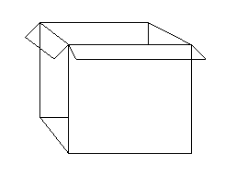
Place all kindergarten materials on top of grade 1 and grade 2 materials.

Box #1

Packaging and Returning “Not To Be Scored” Documents

Review the packing diagram located on the following page. Package all “Not To Be Scored” documents by grade using the box(es) in which the materials were received. Materials should be packed from top to bottom in the following order:

- Completed Forms- Place the completed Return Packing List for “Not To Be Scored” Documents and the Teacher Count Sheets in Box #1.

- Withdrawn Before Testing Started- Preprinted ID Header Sheets (no booklets) for students who withdrew before testing began must be counted and placed in an envelope labeled “Withdrawals”.

- Invalidated Test Booklets for all applicable subtest(s).

- Damaged test booklets.

- Unused blank or damaged ID Header Sheets.

- Directions for Administering SESAT 2, Primary 1 & Primary 2 Directions for Administering the Stanford Select. Directions for Administering the Practice Test for grades K-2.

- Unused test booklets and unused practice tests.

- Count the total number of boxes and label each box using the white labels with black lettering provided by TDC, “Box __ of __.” Fill in the sequence of the boxes being returned (e.g., Box 1 of 2, Box 2 of 2).

- Hand-deliver all documents according to the schedule on page 2.

All test documents in the “To Be Scored” and “Not To Be Scored” boxes must be counted, and the numbers recorded on the return packing lists. The return packing list forms are found in Appendix F.

Packaging and Returning “Not To Be Scored” Documents Diagram

Damaged

Box #1

Withdrawn

Completed Forms
Completed Forms: Return List for “Not To Be Scored” Materials, Teacher Count Sheets
ID Header Sheets for students withdrawn before testing
Invalidated Test Booklets for all applicable subtest(s) (if any)
Damaged Test Booklets (if any)
Unused ID Header Sheets or Damaged ID Header Sheets
Directions for Administering SESAT 2 and Primary 1 & 2 Directions for Administering Stanford Select. Directions for Administering Practice Test (K-2)
Unused Test Booklets and Unused Practice Test Booklets (blank, never used, or unmarked K-2)

Invalidated
If necessary, use additional boxes or envelopes

REPORTING OF RESULTS

Report Production Schedule

SAT-10 reports are provided once all answer documents have been scanned. Following are the projected dates for the release of SAT-10 data reports:

June 2014 Student Listing of Results

July 2014 District and School Summaries posted to ARDA
website

August 2014 Individual Student Reports

The Student Listings of Results should be checked to determine if any students who were tested have missing scores. Missing scores should be reported immediately to Student Assessment and Educational Testing using form 7167, available at http://forms.dadeschools.net/webpdf/7167.pdf

The SAT-10 reports identified above are sent to each school principal; these reports are the only copies available. Duplicate copies are not produced. It is advised that test score printouts be secured in a permanent file as individual student test results are confidential information to be accessed ONLY by the individual student, his/her parents/guardians, and appropriate school professionals. Schools may also access and download students’ scores using the Student Performance Indicators site on the District’s intranet. District and school summary scores are based only on valid student scores.

SAT-10 results are not accessible on the Parent Portal at this time.

APPENDIX A: SAMPLE LETTERS TO PARENTS/GUARDIANS

- ENGLISH VERSION
- HAITIAN-CREOLE VERSION
- SPANISH VERSION

SAMPLE PARENT/GUARDIAN LETTER

(ENGLISH VERSION)

Dear Parents/Guardians:

During the month of April, your son or daughter will take the Stanford Achievement Test, Tenth Edition (SAT-10). The SAT-10 is a standardized test given in the Miami-Dade County Public Schools. The test measures a student’s reading and mathematics skills. Teachers use the test results to plan units and lessons that strengthen students’ skills.

This year, the SAT-10 testing dates are April 7-11, 2014. It is important for your child to be present. This notice is being sent home so that you can note these dates on your calendar and avoid making appointments for your child that would cause him/her to miss taking the test.

Individual Student Reports will be provided as soon as the new school year begins in August. SAT-10 results are not accessible via the Parent Portal.

Thank you for your cooperation. If you have any questions, please contact the school.

Sincerely,

SAMPLE PARENT/GUARDIAN LETTER

(HAITIAN-CREOLE VERSION)

Chè Paran/Gadyen:

Diran mwa avril la pitit gason oubyen fi ou pral pran egzamen ki rele “Stanford Achievement Test, Tenth Edition (SAT-10)” (Egzamen Stanford Akademik 10yèm Edisyon SAT-10). Egzamen SAT-10 la se yon egzamen estandadize yo bay nan Lekòl Leta Miami-Dade County. Egzamen an mezire ladrès lekti ak matematik yon elèv. Pwofesè yo sèvi ak rezilta egzamen an pou planifye chapit ak leson ki ap ranfòse ladrès elèv yo.

Ane sa a n ap bay egzamen SAT-10 jou 7 rive 11 avril 2014. Li enpòtan pou pitit ou prezan. Nou voye avi sa a lakay ou pou w ka make dat yo nan kalandriye w e evite pou w pa fè randevou pou pitit ou a ki ap lakoz li rate egzamen an.

Nou ap voye Rapò Endividyèl Elèv la bay paran yo pi vit posib lè nouvo ane lekòl la kòmanse ann out la. Rezilta SAT-10 pap aksesib atravè Pòtal Paran an.

Mèsi pou koperasyon ou. Si w gen nenpòt kesyon,silvouplè kontakte lekòl la.

Sensèman,

SAMPLE PARENT/GUARDIAN LETTER

(SPANISH VERSION)

Estimados padres de familia/tutores:

Durante el mes de abril, su hijo o hija tomará la prueba Stanford Achievement Test, Tenth Edition (SAT-10). El SAT-10 es una prueba estandarizada que se administra en las Escuelas Públicas del Condado Miami-Dade. La prueba mide las destrezas en lectura y matemáticas del estudiante. Los maestros se valen del resultado de la prueba para planificar las unidades y las lecciones que refuerzan las destrezas de los estudiantes.

Este año, las fechas para la prueba SAT-10 será del 7 al 11 de abril del 2014. Es importante que su hijo se encuentre presente. Esta carta se le envía a su hogar a fin de que usted marque estos días en su calendario y evite concertar citas para su hijo o hija que podría resultar en que no estuvieran presentes para tomar la prueba.

Recibirán los Reportes Individuales de los Estudiantes (Individual Student Reports) tan pronto como comience el nuevo curso escolar en agosto. Los resultados de la prueba SAT-10 no están disponibles por medio del Portal para Padres de Familia.

Muchas gracias por su cooperación. Si tuviese alguna pregunta, por favor, comuníquese con la escuela.

Atentamente,

APPENDIX B: RESPONSIBILITIES OF THE TEST CHAIRPERSON

Test Chair Responsibilities Prior To Testing

- Ensure that the Registrar maintains a listing of students who enroll on or after February 24, 2014.

- Upon receipt of test materials determine if all the boxes in the shipment were received.

- Locate the packing list in the box labeled “PACKING LIST ENCLOSED.” Check the packing list against the actual number of materials received. Immediately report any discrepancies to the TDC.

- Determine whether or not there are sufficient materials to test all eligible students. Order additional materials needed from TDC.

- Save boxes for returning materials.

- Store all test materials in a secure, access-restricted location.

- Work with other school personnel to review student IEPs, Section 504 plans and ELL plans to determine students in need of accommodations and make necessary arrangements.

- Identify students with disabilities who are exempted from testing. (Disability documented on IEP or temporary disability).

- Make testing room arrangements and determine the number of proctors needed.

- Coordinate and send out letters informing parents of the SAT-10 testing.

- Train test administrators and proctors.

- Sort test materials to correspond to the school's testing arrangement.

- Print the name of the student, school, and teacher on the back of the “To Be Scored” test booklets. Do not grid in the student demographic information section on the test booklet.

- Ensure that a sufficient quantity of scratch paper and sharpened #2 pencils are available.

- Prepare Teacher Count Sheet for each day of testing.

During Testing

- Distribute testing materials directly to each test administrator each morning of the
test.

- Ensure that testing rooms are as free from disturbance as possible. Bells should not be rung; access to the intercom should be limited; and access to classrooms should be restricted.

- Ensure that testing rooms have a controlled environment (lighting, temperature, and seating).

- Post Do Not Disturb signs in conspicuous places to help minimize interruptions.

- Seating should be adequately spaced and arranged to discourage cheating.

- Proctors should assist the test administrator before, during, and after the test administration.

- Supervise test administration and be available to answer questions as they arise.

- Report any testing irregularities as per instructions in MDCPS Standards, Guidelines and Procedures for Test Administration and Test Security.

Following Each Test Session

- Complete the Teacher Count Sheet as materials are returned.

- Count all test materials to ensure that all materials have been returned from each test administrator.

- Identify students who were absent and schedule them for make-up.

- Secure testing materials in a locked storage area.

- Call SAET if materials are lost, testing irregularities occur, or if you encounter any problems.

Following the Completion of all Testing

- Collect all testing materials.

- Account for all test booklets (used and unused).

- Remove all paper rulers from test booklets.

- Place students’ completed ID Header Sheets on top of the grid side of the student’s used test booklets.

- Prepare documents for return as specified beginning on page 15.

- Package all documents in the boxes in which the materials were received. These boxes are labeled “Stanford Test.”

- Return all “To Be Scored” documents according to the provided instructions and schedules.

- By May 2, 2014, submit a written account of any missing test booklets and/or testing irregularities violations to the District Director of Student Assessment and Educational Testing, with a copy to the regional superintendent, stating the circumstances and steps taken to guard against reoccurrence.

- Maintain copies of the completed Teacher Count Sheet, Record of Absences, Exemptions, and Invalidations, packing list of “To Be Scored” and “Not To Be Scored” documents for your records for a period of one year.

APPENDIX C: STANDARD: ROLES AND RESPONSIBILITIES FOR IMPLEMENTING TESTING PROGRAMS AT SCHOOL SITES

School administrators, teachers, and other school staff shall all be made aware of their professional obligations with regard to testing programs. The roles and responsibilities of the principal, test chairperson, test administrator, and proctor in the implementation of assessment programs are described below.

Principal
The principal is responsible for ensuring that tests are administered in accordance with professional test administration procedures, as outlined in the administration manuals, program guides, and training materials provided by the test publishers, the state, and/or the District, and for ensuring that any violations of test administration and/or security procedures are reported appropriately and in a timely manner. The principal designates a test chairperson and ensures that the test chairperson attends all mandatory District training sessions and follows established procedures. Although the principal may delegate the coordination of specific testing programs to the test chairperson or another designee, the ultimate responsibility for maintaining the integrity of the test administration rests with the principal. The principal must submit a School Procedural Checklist (FM-6927) at the conclusion of each testing program, to certify that the test administration was conducted in accordance with the District’s established guidelines and procedures.

Test Chairperson
The test chairperson is responsible for organizing and monitoring testing programs at the school level in accordance with the procedures outlined for each program. Primary responsibilities include: attending District training sessions; planning and implementing test administrations; training test administrators and proctors; arranging for testing locations; verifying receipt of test materials; organizing, and distributing materials to the test administrators; maintaining the security of test materials in the schools; supervising test administration; maintaining all required records and documentation; returning test materials for scoring; and maintaining the confidentiality of student test records.

Test Administrator
The test administrator is responsible for directing and conducting student testing sessions, as specified in the administration manuals or program guides. Primary responsibilities include: attending required training sessions; establishing appropriate conditions in the testing room; distributing and returning student test materials; accounting for all assigned materials; strictly adhering to test scripts and directions; actively monitoring students during the testing session; and following security procedures to ensure a standard administration. Only certificated administrative and instructional employees (e.g., teachers, counselors, media specialists) who have received appropriate training for a particular test may serve as test administrators.

Proctor
The proctor is responsible for actively monitoring the testing session and for assisting the test administrator in managing the session and maintaining test security. Administrative, instructional, non-instructional, and paraprofessional employees who have received appropriate training for a particular test may serve as proctors. However, non-certificated employees may only assist in distributing and collecting student test materials under the direct supervision of a certificated test administrator, and may not administer the test, read test scripts, or have sole responsibility for the test materials. In addition, parents or other community volunteers who are trained in proctoring and test security may serve as test proctors, but proctors who are not employees may not handle any test materials or be left alone with students or test materials at any time.
Note that proctors may not be assigned to proctor in a family member’s classroom or at the same grade level as the family member.

Relief Staff
Relief staff who may serve in classrooms in the temporary absence of the regular test administrator or proctor must meet all of the requirements specified for the applicable role, and must have received appropriate training related to test administration and test security procedures.

APPENDIX D: GENERAL TESTING SECURITY GUIDELINES

In order to ensure the integrity of the testing process and the accuracy and validity of all test scores, the District has established specific guidelines and standards. The following are a summary of those provided in the MDCPS Standards, Guidelines and Procedures for Test Administration and Test Security and must be strictly enforced in order to ensure valid test results for all students.

- All personnel are prohibited from examining, reviewing, reading, or copying the test items and/or contents of the students’ tests. The security of all test materials must be maintained before, during, and after the test administration.

- Upon arrival, the testing materials must be signed for by the principal, the assistant principal, the lead teacher, or the test chairperson. All test materials must be counted by the test chairperson. Any discrepancy between the packing list and the materials received must be reported to 305-995-7520.

- At all times except during actual testing, all testing materials will be kept under lock and key and should be under the direct supervision of the principal or test chairperson. All testing materials, including identification header sheets, and test booklets are copyrighted and are not to be copied.

- The materials necessary to conduct actual testing, such as test booklets and program guides, should be given to teachers the morning of testing and picked up immediately following each day's testing. During the testing, no test booklets are to be left unattended.

- All time limits and directions are to be followed exactly, with no deviation in directions or testing time.

- The testing schedule and the proper testing procedures must be reviewed at a meeting with the people who will serve as test administrators and proctors prior to testing. Test administrators and proctors should be familiarized with the program guide and general administration practices and responsibilities. Teachers may review the program guides, but under no circumstances should test booklets be reviewed by the test administrator or proctors.

- The distribution and collection of test booklets to and from students is a critical time because there is the possibility of losing materials. Test materials should be distributed to and received from students on a one-at-a-time basis. The test administrator/proctor can then visually verify that each student has only one test booklet at the beginning of testing and that each student has returned that test booklet at the end of the testing period.

- After the completion of testing, all students should turn their booklets face down and put their pencils away while the orderly collection of materials takes place. All students should remain in their seats until the test administration is completed. Do not allow students to stack their tests and hand them in as a group.

- NO used or unused Stanford-10 testing materials may remain at the school beyond April 16, 2014. (Schools may keep the District-supplied centimeter/inch rulers for use in classroom instruction; used practice tests should be destroyed at the school but practice test directions for administering should be returned.)

- During Stanford testing, District staff members will visit schools. The purpose of these visits will be to monitor the testing of students. Included in the visits will be observations of an actual test administration. Testing monitors may visit schools before and during the testing windows. No school should change its own testing schedule because of a monitor's visit. To ensure a standardized monitoring program, monitors are trained about the aspects of the Stanford -10 testing program that should be observed.

- Under no circumstances may test booklets or ID header sheets be taken outside the school; return of secure materials must be direct; and materials may not be held outside of the school overnight.

- After scoring has been completed, Student Assessment and Educational Testing will conduct an audit of the results.

APPENDIX E: RESPONSIBILITIES OF THE TEST ADMINISTRATOR

Test Administrator Responsibilities Prior To Testing

- Remove or cover any classroom materials that might provide clues to students (e.g. word lists, multiplication chart).

- Arrange classroom and seating arrangements for optimal testing conditions.

- Sign-out the secure SESAT 2/SAT-10 Directions for Administering from the test chairperson prior to the test.

- Account for secure test materials assigned.

During Testing

- Place the Do Not Disturb sign on the door.

- Account for and maintain the security of all testing materials and strictly adhere to test directions and test security procedures to ensure a standard administration.

- Distribute testing materials to each student individually.

- Monitor student progress and provide assistance as directed in the administration manual.

- Complete the Record of Absences, Exemptions, and Invalidations as needed.

- After students have completed a test session, collect test materials individually and account for all materials before returning them to the test chairperson.

Following the Administration

1. Test administrators should collect all testing materials from each student and check the physical condition of each booklet. Any inaccurate information should be corrected in order to prevent conditions which may interfere with the electronic scoring process.

Test administrators are prohibited from reviewing items, problems, passages or
responses with students after testing.

APPENDIX F: FORMS and SIGN

- Do Not Disturb
- Record of Absences, Exemptions, and Invalidations
- Teacher Count Sheet
- Return Packing List for “To Be Scored” Documents
- Return Packing List for “Not To Be Scored” Documents
- School Procedural Checklist
- Sample Student ID Header Sheet
- Sample of SAT-10 Test Booklet Back Cover

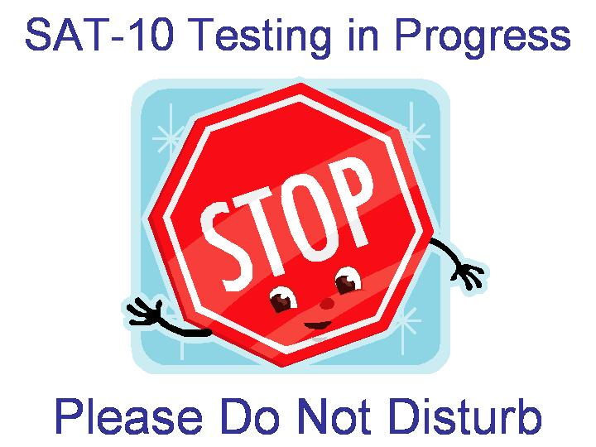
DO NOT DISTURB SIGN

MIAMI-DADE COUNTY PUBLIC SCHOOLS
STANFORD ACHIEVEMENT TESTING PROGRAM

RECORD OF ABSENCES, EXEMPTIONS, AND INVALIDATIONS

Assessment Date: April /2014__________ (Month/Year)

Name of School: _____________________________________________ School Location Number: _____________

Name of Test Administrator: ___________________________

STUDENT’S NAME | GRADE | CODE  A = Absence  E = Exemption  I = Invalidation | SUBTEST  R = Reading Comprehension or Sentence Reading  M = Mathematics: Problem Solving or Mathematics | REASON
Place the completed form in Box #1 of the “To Be Scored” test documents. The test chairperson should retain a copy of this form for one year following the assessment date.
DUPLICATE AS NEEDED FM-5183 Rev. (01-08)
MIAMI-DADE COUNTY PUBLIC SCHOOLS
STANFORD ACHIEVEMENT TESTING PROGRAM

TEACHER COUNT SHEET

School Name: _____________________________________________________________ School Number: ____________

Directions: Record the teacher’s name and quantity of test booklets, ID Header Sheets, program guide, and/or administration script assigned to each test administrator. Teachers must certify receipt/return by initialing this form when picking up materials prior to testing and again when returning materials after testing.

Teacher’s  Name | Number of Test Booklets | Number of ID Header Sheets | Number of Copies of the Directions for Administering | Date  __/__/__  Receipt/  Return and Initials |  | Date  __/__/__  Receipt/  Return and Initials

Test Chairperson’s Signature: _________________________________________________ Date: ___________________

Place this completed form in Box #1 of the “Not To Be Scored” documents. Retain a copy of the completed form at the school for one year following the administration date.

DUPLICATE AS NEEDED M-4661 Rev. (01-08)
37
MIAMI-DADE COUNTY PUBLIC SCHOOLS

RETURN PACKING LIST FOR “TO BE SCORED” DOCUMENTS
20__ ADMINISTRATION

School Name:___________________________________ School Number:_________

Directions: Complete this form by writing in the number of “To Be Scored” documents returned.

Coded ID Header Sheets submitted for any student who had all applicable subtests invalidated, or who was absent or exempt for all applicable subtests. | Number of Coded  ID Header Sheets Only
 | Kindergarten | Grade 1 | Grade 2
Invalidated for all applicable subtests--- coded # 2
Absent for all applicable subtests--- coded # 1
Not Tested---Exempt---Exceptional--- coded A
Not Tested---Other--- coded H
Total Number Submitted
“To Be Scored”  Test Booklets/ID Header Sheets | Kindergarten | Grade 1 | Grade 2
Florida Home Education (Coded school number 8015)
Miami-Dade Online Academy (Coded school number 7001)

“To Be Scored”  Test Booklets/ID Header Sheets | Kindergarten | Grade 1 | Grade 2
Your school’s documents

Do not include counts for any Special Documents (VI) or “Not To Be Scored” documents on this form.
______________________________________ ____________
Test Chairperson’s Signature Date

Place this completed form in Box #1. Retain a copy of the completed form at the school for one year following the administration date.

Total Number of “To Be Scored” Boxes from School:________

DUPLICATE AS NEEDED FM-6677 (01-09)

MIAMI-DADE COUNTY PUBLIC SCHOOLS

RETURN PACKING LIST FOR “NOT TO BE SCORED” DOCUMENTS
20__ ADMINISTRATION

School Name:___________________________________ School Number:_________

Directions: Complete this form by writing in the number of “Not To Be Scored” documents returned.

Secure Testing Materials  “Not To Be Scored” | Number of Materials Returned
Secure Testing Materials  “Not To Be Scored” | Kindergarten | Grade 1 | Grade 2
Invalidated Test Booklets for all applicable subtests
Damaged Test Booklets
Unused Test Booklets
Directions for Administering
Additional Testing Materials
“Not To Be Scored”
ID Header Sheets for Withdrawals
Unused ID Header Sheets (Blank or Damaged)
Unused Practice Tests
Directions for Administering Practice Test

Do not include counts for any “To Be Scored” documents on this form.

______________________________________ ________________
Test Chairperson’s Signature Date

Place this completed form in Box #1. Retain a copy of the completed form at the school for one year following the administration date.

Total Number of “Not To Be Scored” Boxes from School: ________

DUPLICATE AS NEEDED FM-6678 (01-09)

MIAMI-DADE COUNTY PUBLIC SCHOOLS

SCHOOL PROCEDURAL CHECKLIST

SAT-10 TESTING PROGRAM

Documentation that the SAT-10 Administration at each school was supervised by the principal in accordance with the guidelines and procedures established by Miami-Dade County Public School District is required. To comply with this requirement, this form must be completed by the school principal and the test chairperson and returned with the “To Be Scored” testing materials on April 11-16, 2014.

We certify that, to our knowledge, all guidelines and procedures outlined in the Stanford Achievement Test Program Guide/Test Administration manual have been strictly adhered to at this school, and that each of the following specific processes has taken place as prescribed; as noted below:

Yes No
___ ___ All SAT-10 testing materials were received and counted, and any discrepancies were reported and reconciled with the Test Distribution Center prior to the test administration. After reconciliations, if any, our school had sufficient quantities of _______Test________ materials to conduct testing.

___ ___ Prior to the test administration, all staff involved in the SAT-10 administration were trained on appropriate test administration and security procedures. The Test Security Guidelines/Procedures were reviewed with all persons administering or having access to test booklets either in a faculty meeting, a grade group or department meeting, or individually, if absent from scheduled group meetings.

___ ___ The SAT-10 was administered following the explicit directions stated in the appropriate grade level test administration manual to assure test standardization.

___ ___ Following testing, all test materials were accounted for according to the guidelines in the Stanford Achievement manual. Any missing materials reported, by telephone and in writing, to Student Assessment and Educational Testing.

___ ___ All “To Be Scored” documents were delivered to their prescribed destination on the designated date(s).

___ ___ All “Not To Be Scored” materials were delivered to their prescribed destination on the designated date(s), according to the program guidelines.

______________________________ _____________________________
Principal’s Signature Date

______________________________ _____________________________
Test Chairperson’s Signature Date

______________________________ _____________________________
School Name School Number

If any item was marked “No”, a written report of any exceptions to the above procedures must be attached to this checklist when submitted. FM-6927 (09-05)

Sample Grade K-3 Student Identification (ID) Header Sheet

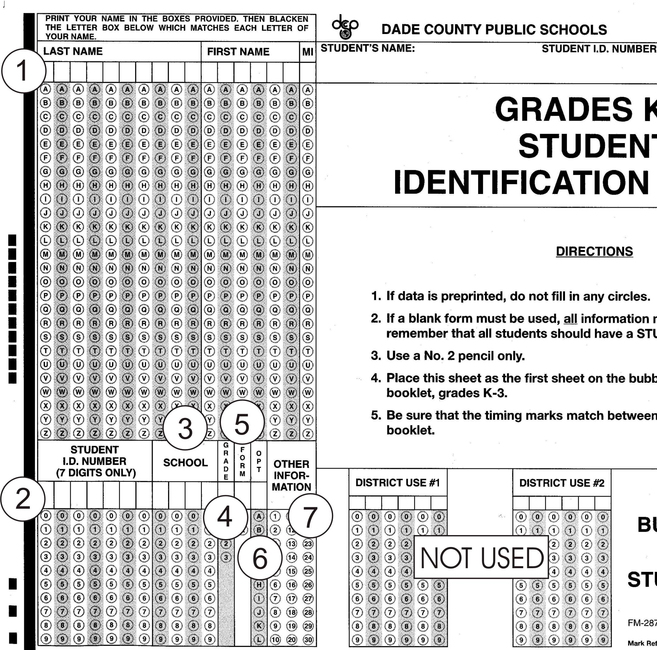

1 = NAME - Beginning at the left: Student's last name, first name, and middle initial
2 = STUDENT'S ID NUMBER - Student's 7-digit ID number
3 = SCHOOL - School's 4-digit location number
4 = GRADE - Student's grade level
5 = FORM - Obsolete (Leave Blank)
6 = OPT(ional):
A = Not Tested - Exempt – Exceptional
H = Not Tested - Other
7 = OTHER INFORMATION - Code absent, invalid, or accommodation, by subtest, as appropriate.
See chart on page 9.

Sample of SAT-10 Test Booklet Back Cover
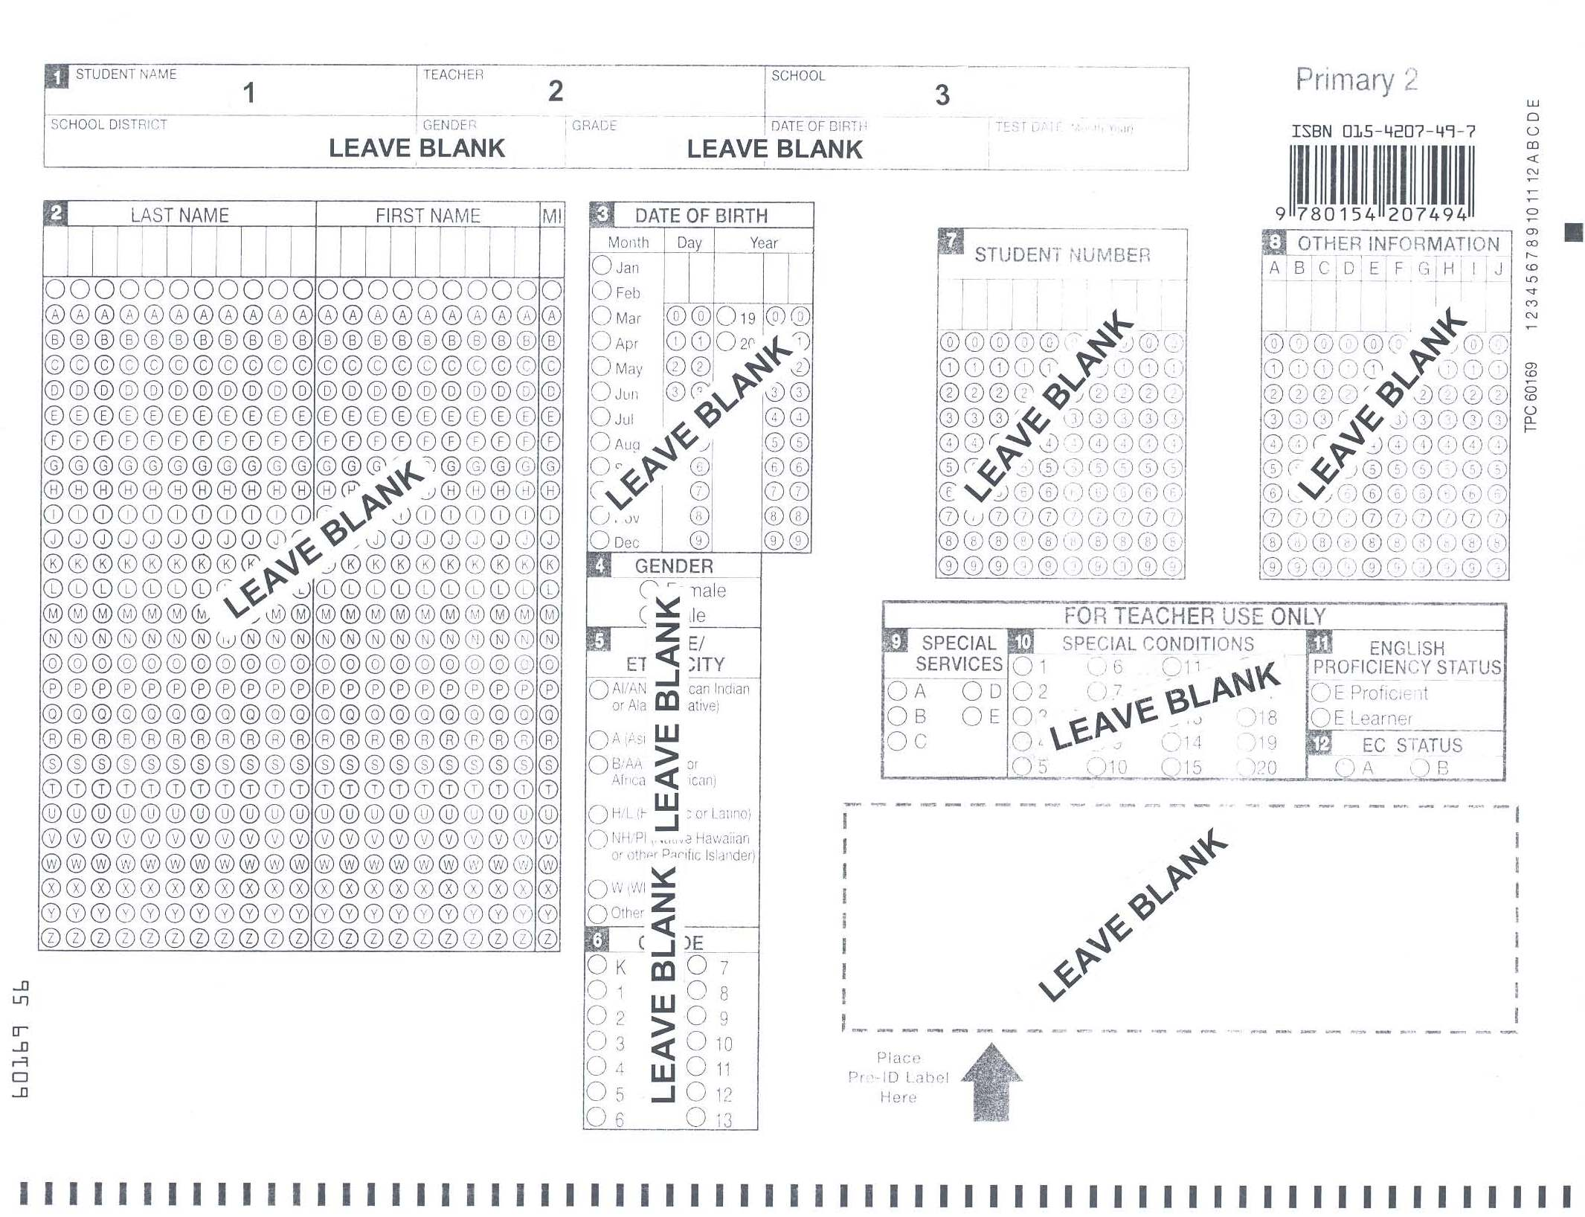

APPENDIX G: WHO TO CONTACT FOR INFORMATION

For information about when to test, who to test, testing procedures, and testing accommodations, please contact:

Ms. Mayda Cabeza, Director I
Student Assessment and Educational Testing
1450 NE 2nd Ave. Suite 208
Mail Code: 9023
Phone Number: 305-995-7520
Fax Number: 305- 995-7522
Email: MCabeza@dadeschools.net

For additional testing materials and information on how to pack and when to deliver materials, please contact:

Ms. Magaly Hernandez, Supervisor I
Test Distribution Center (TDC)
13135 S.W. 26 Street
Mail Code: 9038
Phone Number: 305- 995-3743
Fax Number: 305- 995-3963
Email: mrhernandez@dadeschools.net

http://oada.dadeschools.net/TestChairInfo/InfoForTestChair.asp

Additional copies of this program guide may be downloaded from the following web page.

