Miami-Dade County Public Schools
Program Guide
Summer 2014
Alternative Assessment for
Grade 3 Promotion

Summer Reading Camp


Assessment, Research, and Data Analysis
Student Assessment and Educational Testing

Miami-Dade County Public Schools

School Board Members

Ms. Perla Tabares Hantman, Chair
Dr. Lawrence S. Feldman, Vice Chair
Dr. Dorothy Bendross-Mindingall
Ms. Susie V Castillo
Mr. Carlos L. Curbelo
Dr. Wilbert “Tee” Holloway
Dr. Martin Karp
Dr. Marta Perez
Ms. Raquel A. Regalado

Ms. Krisna Mady, Student Advisor

Superintendent of Schools
Mr. Alberto M. Carvalho, Superintendent of Schools



Table of Contents

Introduction 1
Schedule Of Activities 2
Students to be Tested 3
Accommodations 3
Test Accommodations for English Language Learners (ELL) 3
Test Accommodations for Students with Disabilities and Section 504 Students 4
Preparing for Testing 5
Receiving and Preparing Materials for Testing 5
Test Booklets 6
ID Header Sheets 6
Training of Test Administrators and Proctors 6
Coding For Absences, Invalidations, Accommodations – “Other Information” Field on ID Header Sheets 7
Distribution and Tracking of Materials 7
Administering the Test 8
Materials Required for Test Administration 8
Recommended Time of Day to Test 8
Test Timing 8
Directions For Administration 9
General Information About Answer Documents 9
Test Room Conditions 9
Clarifying Directions 9
Absences and Invalidations 9
Students Who Are Absent 9
Students Who Arrive Late 10
Test Invalidation 10
Damaged Test Booklets 10
Packing and Returning Testing Materials 11
Preparing Test Booklets and ID Header Sheets for Return 11
Packing and Returning “To Be Scored” and “Not To Be Scored” Materials 12
Packing and Returning All Testing Materials 14
Reporting of Results 15
Appendix A: Standard Roles and Responsibilities for Implementing Testing Programs at School Sites 16
Principal 16
Test Chairperson 16
Test Administrator 16
Proctor 17
Relief Staff 17
Appendix B: General Testing Security Guidelines 18
Appendix C: Responsibilities of the Test Chairperson 20
Test Chair Responsibilities Prior To Testing 20
During Testing 21
Following Each Test Session 21
Following the Completion of all Testing 21
Appendix D: Forms and Sign 23
Do Not Disturb Sign 24
Record Of Absences, Exemptions, And Invalidations 25
Teacher Count Sheet 26
Return Packing List For “To Be Scored” Materials 27
Return Packing List For “Not To Be Scored” Materials 28
School Procedural Checklist 29
Sample Alternative Assessment Grade 3 (ID) Header Sheet 30
Appendix E: Script for Administering the Test 31
Appendix F: Sources of Information 34

INTRODUCTION

During the last week of the 2014 summer school session, the Alternative Assessment for Grade 3 Promotion (AAGTP) will be administered to all eligible retained third grade students. The AAGTP assesses students’ reading comprehension skills. The District will scan and score the tests and will provide school listings of student results prior to the start of the 2014-15 school year to allow for proper placement. Individual student reports will be provided for distribution to parents.

As required by the statewide public school student progression law eliminating social promotion, Section 1008.25, Florida Statutes, a student may be promoted to grade 4 if the student demonstrates an acceptable level of performance in reading. In order to be promoted, students must demonstrate reading mastery on one of the following:

- Florida Comprehensive Assessment Test 2.0 (FCAT 2.0) Reading,
or
- Grade 3 Reading Student Portfolio,
or
- Alternative Standardized Reading Assessment,
or
- Alternative Assessment for Grade 3 Promotion,
or
- Grade 3 Mid-Year Promotion.

The AAGTP will serve the State of Florida’s promotion decision purpose only if sound testing practices are followed. To ensure that these practices are followed, school personnel must conscientiously adhere to the recognized test administration principles that govern standardized testing and are addressed in this administration guide. See Appendix A for a general description of the role of the principal, test chairperson, test administrator, and proctor in the assessment. See Appendix B for general test security guidelines and the Miami-Dade County Public Schools’ Standards, Guidelines, and Procedures for Test Administration and Test Security for additional details.

SCHEDULE OF ACTIVITIES

June 9-27 Screencast training for summer test chairpersons.

June 27 Deadline to complete the online screencast verification form via
http://www.surveymonkey.com/s/Z66M3LD

July 21-22 Delivery of the AAGTP test materials to schools via Comet Delivery Services.

July 30 Administration of the AAGTP to all eligible retained third grade students.

July 31 Make-up administration, as necessary.

August 1 Schools return all “To Be Scored” materials, “Not To Be Scored” materials and District Coordinator Envelopes to the Test Distribution Center (TDC) by 3:30 p.m.

August 12 (Tentative) School Listing of Results available for pick up by schools at Instructional Technology Services (ITS).

August 25-29 Comet Delivery Services delivers Individual Student Reports (ISRs) to schools.

STUDENTS TO BE TESTED

The Alternative Assessment for Grade 3 Promotion (AAGTP) is to be administered to all eligible retained third grade students during the 2012 summer school session, on July 30- July 31, 2014. A student is only eligible to participate in this assessment if he/she was retained based on the 2013-14 FCAT 2.0 Reading score and has not met one of the following “good cause” criteria:
- English Language Learners (ELLs) with less than two years in an English for Speakers of Other Languages (ESOL) program,
- Students with disabilities whose individual educational plan (IEP) indicates that participation in the FCAT 2.0 is not appropriate,
- Students who demonstrate reading proficiency in accordance with the Next Generation Sunshine State Standards (NGSSS) Benchmarks of Language Arts through the Grade 3 Reading Student Portfolio,
- Students with disabilities who participate in the FCAT 2.0, but still demonstrate a deficiency in reading after more than two years of intensive remediation, and were previously retained in kindergarten, first, second, or third grade, and
- Students who still demonstrate a deficiency in reading after two or more years of intensive remediation and were previously retained in kindergarten, first, second, or third grade for a total of two years.
It is strongly recommended that any student who did not meet the requirements for promotion should attend summer school and participate in the AAGTP. The district will provide each opened summer school with a list of retained third grade students from neighboring feeder schools. Students who do not attend summer school are also eligible to participate in the assessment, and should be accommodated to the extent possible on the designated dates. All testing, including make ups, must be completed during the testing window.

Home Education and McKay Scholarship students are not eligible to participate in the AAGTP.

Accommodations

Test Accommodations for English Language Learners (ELLs)

Consideration must be given to the scheduling of ELL students who are eligible for accommodations. ELLs in ESOL levels 1-4 are eligible for accommodations regardless of time in the ESOL program. Determination of appropriate accommodations for an ELL must be made by the student’s ESOL teacher and be based on the individual needs of the student. If a student is determined to be in need of accommodations, accommodations must be provided. See the Coding for Absences, Invalidations, Accommodations (“Other Information” Field) section on page 5 for coding information. The following accommodations are permitted, if deemed appropriate:

- Flexible Setting: ELLs may be offered the opportunity to be tested in a separate room with the ESOL or heritage language teacher acting as the test administrator.

- Flexible Scheduling: Students may take the test during several brief sessions within one school day. The test should be administered at a time of day that is most beneficial to the student.

- Flexible Timing: Students may be provided additional time.

- Assistance in the Heritage Language: The ESOL teacher may answer questions about the general test directions in a way that the students are not lead to infer the correct answers. The teacher is prohibited from reading words to the students from the passages and test questions and from answering questions about the passages and test questions.

- Dictionary: Students must have access to an English-to-heritage language translation dictionary and/or heritage language-to-English translation dictionary, such as those made available to ELL in the instructional setting. However, a dictionary providing definitions writ ten exclusively in the heritage language or in English cannot be provided.

Test Accommodations for Students with Disabilities and Section 504 Students

Participating students with disabilities who have active IEPs or students classified as Section 504 students who have active Section 504 Accommodation Plans may be provided with testing accommodations. Teachers must follow the procedures for accommodations outlined below and give special assistance only to those students who are eligible for such assistance, as per the current IEP or Section 504 Accommodation Plan. If a student is determined to be in need of accommodations, accommodations must be provided. See Coding for Absences/Invalidations/Accommodations (“Other Information” Field) section for coding information.

The following test accommodations are permitted, if deemed appropriate:

- Flexible Setting: Students may take the test individually or in a small group setting, under a test administrator’s supervision. Lighting, acoustics, adaptive or special furniture, and distraction-free locations should be considered for flexible setting situations.

- Flexible Scheduling: Students may take the test during several brief sessions within one school day (summer school hours). The test should be administered at a time of day that is most beneficial to the student.

- Flexible Timing: Students may be provided additional time within the summer school hours.

- Recording of Answers: Students may mark answers in the test booklets or indicate the selected answers to a test administrator by pointing or verbally responding. If students indicate the answers, the proctor must record the students’ responses into the test booklets.

- Flexible Presentation: Students may use a magnifying device, a pointer, a noncalibrated ruler or template, or other similar device to assist in maintaining visual attention to the test booklet.

- Dictionary: Students who use sign language as their primary means of communication may use an English/sign or sign/English translation dictionary.

- Revised Format: Students may be tested by one of the following methods.

  - Visual Reading: Students may be tested with large print materials.
  - Tactile Reading: Students may be tested with materials that have been transformed to Braille code. These materials must be provided for students who meet the eligibility for the visually impaired program.
  - Sign Language Presentations: The test administrator may sign directions, but not the reading passages or items. This modification may be provided to students who meet the eligibility for the deaf or hard of hearing program.

Because the AAGTP is a reading test,
reading passages and items
MUST NOT
be read to students as an accommodation.

PREPARING FOR TESTING

Receiving and Preparing Materials for Testing

The Stanford Achievement Test, Tenth Edition, Primary 3, will be administered as the AAGTP in summer 2014. When the test materials are received by the school, they must be inventoried to make sure that all shipped materials were received, and that sufficient materials are available to test all eligible students. The Test Distribution Center (TDC) will provide each open summer-school center with sufficient overage to accommodate eligible students from neighboring feeder schools that are not opened for summer school.

Any materials on the packing slip that were not received must be reported immediately to TDC. The materials must be stored in a secure, access-restricted location in the school. Test materials include: test booklets, ID Header Sheets, and administration scripts.

Test Booklets

For all students tested, the following information must be handwritten on the top line on the back of each booklet; all other spaces should be left blank. The handwritten information is necessary in order to match the students’ test booklets and ID headers for proper scanning/scoring.

- Student’s Name
- Teacher Name
- School Name (summer school site where tested)

Do not bubble the student’s name or other identifying information on the back of the test booklet.

ID Header Sheets

Identification information for all retained Grade 3 students was generated on student ID Header Sheets as of July 8, 2014. Students with the pre-printed ID Header sheets are those on the student lists of retained students from neighboring feeder schools that were provided by the district. If a student does not have a preprinted ID Header Sheet, his or her eligibility must be verified and the following information must be handwritten and hand-bubbled on a blank ID Header Sheet, using a #2 black lead pencil.

- Student’s Name (last name, first name, and middle initial)
- Student’s M-DCPS ID Number (7 digits)
- School Number for summer school site (4 digits)
- Student’s Current Grade

NOTE: Only one form of the test will be used; therefore, the “Form” designation on the Header Sheet is to be left blank.

Training of Test Administrators and Proctors

Prior to the administration of the test, review and become familiar with this guide and with the testing materials. Review the Responsibilities of the Test Chairperson (Appendix C) as a step by step guide to ensure all procedures are followed for the AAGTP administration.

Conduct training sessions for all test administrators and proctors. The training should include a review of the following:

- Who must be tested
- School’s testing schedule
- Administration procedures, including
° Test room conditions
° Students who arrive late
° Clarifying directions
° Administration script
° Testing time limits
° Providing accommodations
° Test invalidation

- Standard Roles and Responsibilities for Implementing Testing Programs at School Sites (Appendix A)
- District’s General Testing Security Guidelines (Appendix B)

Coding For Absences, Invalidations, Accommodations – “Other Information” Field on ID Header Sheets

If the student was absent, the test was invalidated, or the student received a test accommodation, the applicable code must be hand-bubbled in the “OTHER INFORMATION” field of the ID Header Sheet using the codes listed in the table below.

Student Was Absent  During Administration Window | Test Booklet Was  Invalidated | Student Received  Accommodations
5 | 6 | 9

Coded ID Header Sheets must be submitted for all eligible students who registered for the AAGTP but did not take the test in a regular or make-up session.

DISTRIBUTION AND TRACKING OF MATERIALS

Test booklets, and test administration scripts do not include security numbers. However, these test materials should be considered secure materials. Test chairpersons are required to account for the number of test booklets and test administration scripts distributed to each test administrator. The Teacher Count Sheet provided in Appendix D, should be used for each test session to account for materials.

Test administrators are responsible for signing in/out and counting the number of test booklets and test administration scripts assigned to them. When test administrators complete a test session, they must return all assigned test materials to the test chairperson. The test chairperson is then responsible for counting the materials and verifying that the assigned number of test materials is returned.

ADMINISTERING THE TEST

Materials Required for Test Administration
- Test Booklets and ID Header Sheets. Each student will have a test booklet and an ID Header Sheet. Students will write their responses directly in the test booklet. The ID Header Sheet serves as the document to record student demographic information and test codes. The student’s ID Header Sheet will be placed on top of the bubble grid face of the test booklet after testing is completed.

- Pencils. Students must use #2 black lead pencils. Students should be told to bring two pencils for the test. A supply of sharpened pencils should be available for students who forget. Mechanical pencils cannot be used because their markings cannot be identified by the scanning devices used to read and score student responses.

- Script for Administering the Test. Each test administrator must have and use the test administration script in Appendix E. Duplicate the scripts, as needed, but all copies must be accounted for.

- Do Not Disturb Sign. Duplicate the sign in Appendix D. Place a sign on the outside door of each testing room.

- Please note that practice tests are not administered as part of the Alternative Assessment for Grade 3 Promotion program.

Recommended Time of Day to Test

A morning administration of the test is strongly recommended. Research indicates that test takers tend to perform better in the morning hours prior to lunch. In order to maximize test security and ensure the validity of the test results, it is strongly recommended that all students at a school be tested at the same time of the day (e.g., starting at 8:30 a.m.) rather than spreading testing sessions over the course of the day.

Test Timing

The AAGTP is an untimed test; the approximate time limits provided below are suggested times for planning the administration only. Accordingly, students who need additional time to complete the assessment should be allowed to complete the test. Accommodations apply to ESE and ELL students as determined appropriate. The administration will require approximately 10 minutes preparation time in addition to the actual testing time. The preparation time allows for handing out and collecting testing materials, reading test directions, and going over the samples items that are part of the test administration script.

Approximate  Preparation Time | Approximate  Administration Time
10 minutes | 50 minutes

Directions For Administration

General Information About Answer Documents

Student identification information is recorded on a scannable ID Header Sheet and the student responses are marked directly on the test booklet. Therefore, every student tested will have a set of test materials (ID Header Sheet and test booklet).

Test Room Conditions

The test must be administered in a room that allows for comfortable seating, good lighting, and freedom from distractions. A student’s writing space must be large enough to accommodate the test booklet. The use of lap boards is not recommended.

Clarifying Directions

Although directions must be read as stated in the script for administering the test, directions may be clarified. Assistance may be given as long as it is limited to explaining the marking of answers, following directions, and finding the right place in the test booklets.

Test administrators may not provide students with assistance that will inadvertently indicate an answer to an item. The test administrators should simply advise students to do their best and attempt to answer every item because students’ scores are based on the total number of correct answers.

Absences and Invalidations

Students Who Are Absent

If registered students are absent during the testing window, the school must write the names of the students on the Record of Absences, Exemptions, and Invalidations Form in Appendix D. Additionally, the number 5 must be hand-bubbled in the column entitled “OTHER INFORMATION” on the student’s ID Header Sheet. See the Coding for Absences, Invalidations, Accommodations (“Other Information” Field) section for coding information on page 7. Place the coded ID Header Sheet(s) into a manila envelope and label the envelope “ABSENT.”

Students Who Arrive Late

Students who attempt to enter the classroom after the actual testing has begun must be instructed to return to the school office. The students should be counted as absent, and their names should be placed on the make-up testing list.

Test Invalidation

Circumstances may require invalidation of a student’s test or the tests for a group of students. Based on professional judgment, invalid testing may include but it is not limited to the following:

- A student becomes ill or leaves the room during testing.
- A student fails to follow instructions (e.g., refuses to mark responses).
- A student exhibits behavior that disrupts other students.
- A student is observed giving assistance, receiving assistance, or continuing to answer questions after time is called.
- An error occurs in the actual test administration.
- A disturbance or distraction occurs that could affect scores.

In order to document the reason for invalidation, the school must note the student’s name and record the reason on the Record of Absences, Exemptions, and Invalidations Form in Appendix D. Additionally, the ID Header Sheet must be hand bubbled with a number 6 in the column entitled “Other Information,” see page 7 for coding information. Place the coded ID Header Sheet(s) and test booklets into a manila envelope and label the envelope “INVALIDATIONS.”

If a group invalidation occurs, the school must immediately call the office of Student Assessment and Educational Testing to explain the reasons for the invalidation. In addition, a follow-up explanatory memorandum must be faxed to the District Director, Student Assessment and Educational Testing, at 305-995-7522.

If a test is invalidated, there is no other opportunity or test during this administration that can be given to the student(s) for promotion decisions.

Damaged Test Booklets

Occasionally a test booklet is damaged (e.g., torn, student used ink, student became ill on document). When this occurs, the test administrator should do the following:

- Transfer all student identification information and student responses into a new test booklet.
- Write “DAMAGED” across the front of the damaged test booklet.
- Verify that all transferred information has been correctly gridded and submit the replacement test booklet with the other test booklets for scoring.
- Place the damaged test booklets(s) in a manila envelope and label the envelope “DAMAGED.”

PACKING AND RETURNING TESTING MATERIALS

Note: All testing materials must be returned to the TDC. No testing materials may be kept at a school or destroyed by a school.

Preparing Test Booklets and ID Header Sheets for Return

- Account for all test booklets (used and unused).

- Be sure you have ID Header Sheets for all students who the District identified as retained third grade students registered at your summer school site, including students who were absent or withdrawn.

- Count the number of ID Header Sheets for students who were absent and the ID Header Sheets and test booklets for students who had their test invalidated. Record this information on the Return Packing List for “To Be Scored” Materials Form in Appendix D.

- On preprinted ID Header Sheets, be sure that all added hand gridded information is correct (e.g., accommodations code).

- For students who did not have preprinted ID Header Sheets, be sure that all the student’s identification information and all applicable coding is accurately bubbled.

- Be sure you have a “To Be Scored” set (test booklet and ID Header Sheet) for each student who took the test.

- Be sure the student’s, school’s, and teacher’s name are recorded on the back of all the “To Be Scored” test booklets. Do not grid in the student demographic information section on the test booklet.

- Place the student’s completed ID Header Sheet on top of the grid side of the student’s used test booklet.

- Count the number of “To Be Scored” sets (test booklet and ID Header Sheet) for each student who took the test. Complete the Return Packing List for “To Be Scored” Materials Form in Appendix D.

- Count the number of damaged test booklets, unused non-preprinted ID Header Sheets, administration scripts, and program guides. Complete the Return Packing List for “Not To Be Scored” Materials Form in Appendix D.

Packing and Returning “To Be Scored” and “Not To Be Scored” Materials

- “To Be Scored” Materials and “Not To Be Scored” Materials may be packaged in the same box for the AAGTP program, if the quantity of materials allow. If multiple boxes are used, they should be numbered sequentially (i.e., Box 1 of 2 )

- Ensure that the matching ID Header Sheet is on top of the grid face of the student’s test booklet. Align the black timing marks to ensure all test booklets are facing the same direction.

- Separate the hand-bubbled ID Header Sheets (bubble grid face up) and corresponding test booklets from the preprinted ID Header Sheets and corresponding test booklets.

- Package all used and unused testing materials in the box(es) in which the materials were received. Refer to the diagram on page 13.

- Place the “Not To Be Scored” Materials inside the box, including unused non-preprinted ID Header Sheets, unused test booklets, program guides, and administration scripts.

- Place the “To Be Scored” Materials test booklets and ID Header Sheets inside the box in the following order: (1) hand-bubbled ID Header Sheets and test booklets and (2) preprinted ID Header Sheets and test booklets.

- If you have any manila envelopes labeled “Absent,” “Damaged,” and/or “Invalidations,” place them on top of the materials in Box #1.

- District Coordinator Envelope: Place the completed Record of Absences, Exemptions, and Invalidations Form, Return Packing List For “To Be Scored” Materials Form, Return Packing List for “Not To Be Scored” Materials Form, Teacher Count Sheet, and the School Procedural Checklist in a manila envelope marked “District Coordinator” and place inside box #1.

- Count the number of boxes and label each box with the labels provided by the TDC. Fill in the sequence of boxes being returned (e.g., Box 1 of 2, Box 2 of 2).

- Testing materials for visually impaired students must be returned in the large box or envelope in which they were initially received. Please make sure to transcribe the student’s answers on the regular test booklet provided.

Hand-deliver the box(es) of testing materials to the TDC no later than 3:30 p.m. on August 1, 2014.

Packing and Returning All Testing Materials
for the Alternative Assessment
District Coordinator Envelope:
Copies of the following completed forms:
Record of Absences, Exemptions and Invalidations
Return Packing List for “To Be Scored” Materials
Return Packing List for “Not To Be Scored” Materials
Teacher Count Sheet
School Procedural Checklist
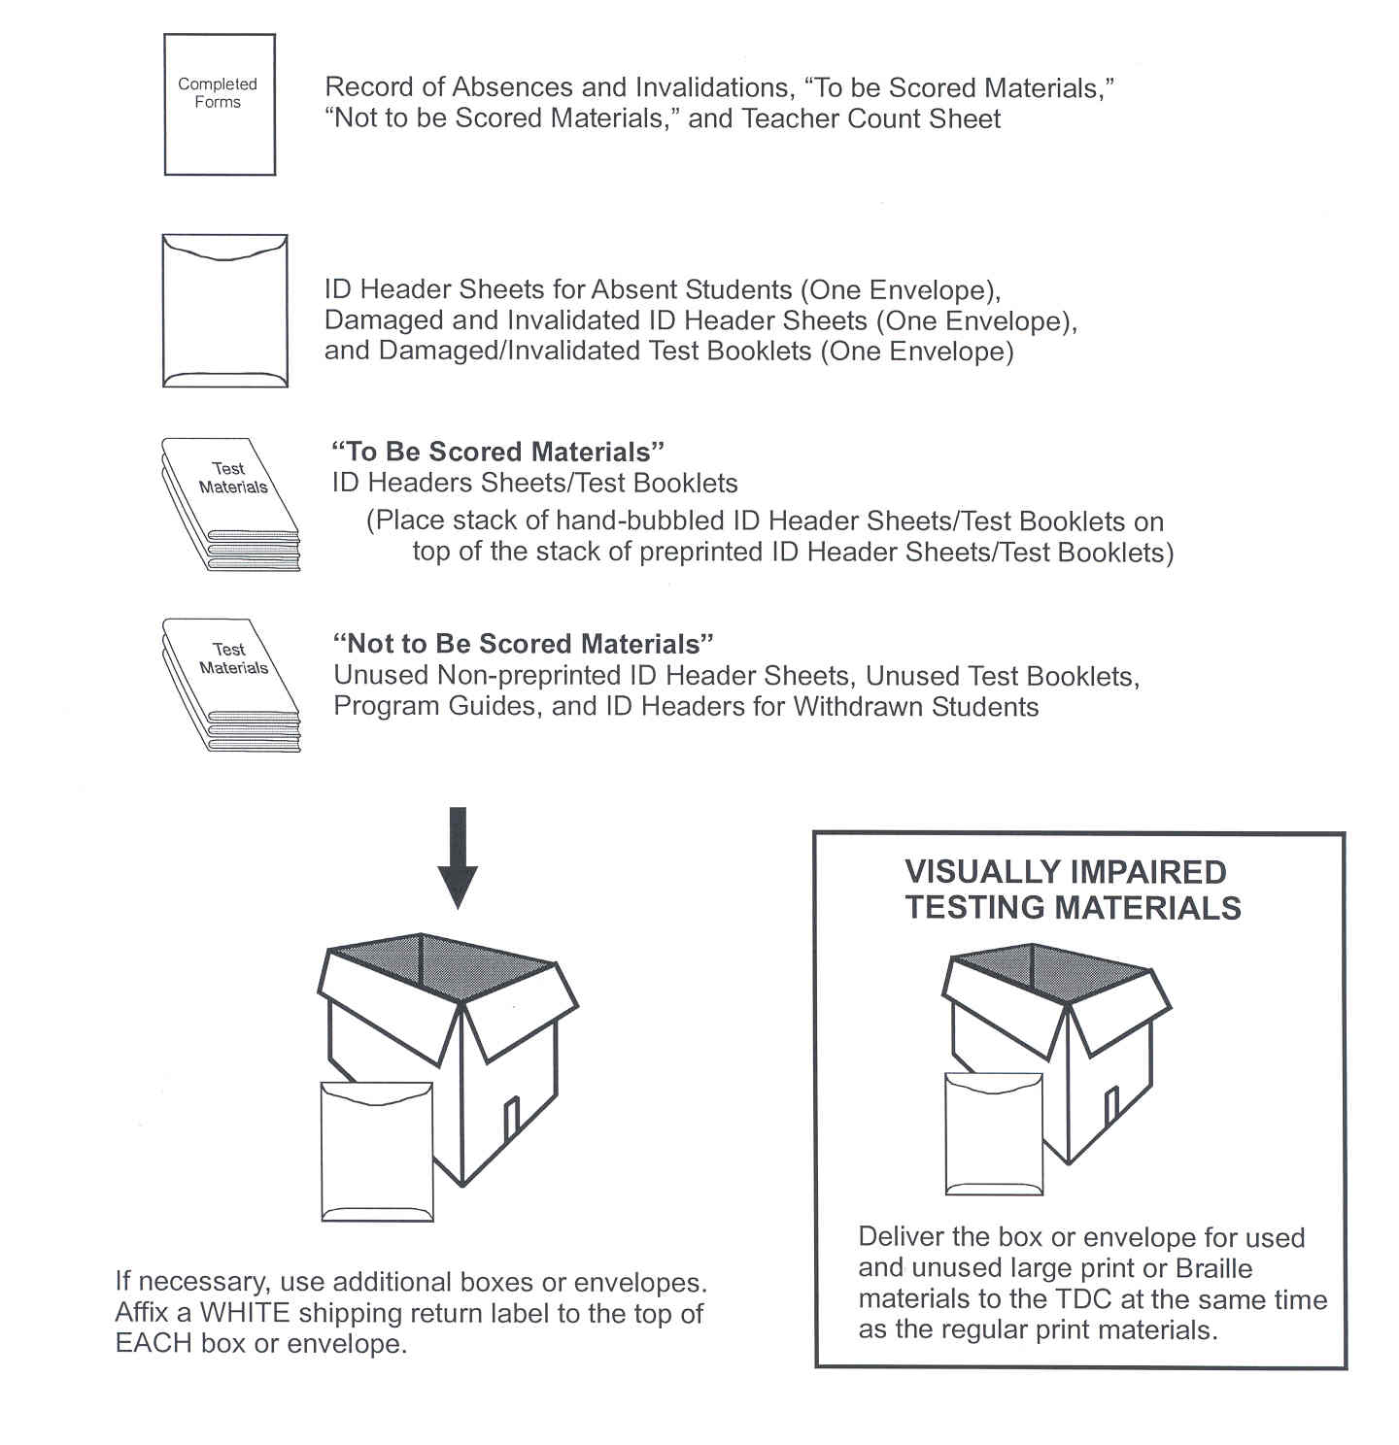
“To Be Scored” Materials
ID Header Sheets/Test Booklets
(Place stack of hand-bubbled ID Header Sheets/Test Booklets on top of the stack of preprinted ID Header Sheets/Test Booklets)
“ABSENT” Envelope
“INVALIDATED” Envelope (ID Header Sheets/test booklets)
“DAMAGED” Envelope (ID Header Sheets/test booklets)

“Not To Be Scored” Materials
Unused non-preprinted ID Header Sheets
Unused Test Booklets
Program Guides
Administration Scripts
If necessary, use additional boxes or envelopes. Affix a WHITE shipping return label to the top of EACH box or envelope and number accordingly.
Return the box or envelope for used and unused large print or Braille materials to the TDC at the same time as the regular print materials.

District
Coordinator

REPORTING OF RESULTS

A School Listing of Student Results will be produced with students listed alphabetically by home school, and will include the percentile rank achieved by each student who took the test. Students who score at or above the 45th percentile on the AAGTP meet the criteria for promotion to Grade 4.

Schools may pick up the School Listing of Results at ITS beginning on August 12, 2014. However, this date is tentative. SAET will notify schools if there are any changes. These lists should be used to facilitate promotion decisions, inform parents, and ensure proper placement prior to the first day of school. Questions regarding missing scores and or requests for answer document review should be directed to Student Assessment and Educational Testing at 305-995-7520 following receipt of the reports.

In addition, Individual Student Reports to be distributed to the parents will be delivered by Comet Delivery Services August 25- 29, 2014.

APPENDIX A: STANDARD ROLES AND RESPONSIBILITIES FOR IMPLEMENTING TESTING PROGRAMS AT SCHOOL SITES

School administrators, teachers, and other school staff shall all be made aware of their professional obligations with regard to testing programs. The roles and responsibilities of the principal, test chairperson, test administrator, and proctor in the implementation of assessment programs are described below.

Principal
The principal is responsible for ensuring that tests are administered in accordance with professional test administration procedures, as outlined in the administration manuals, program guides, and training materials provided by the test publishers, the state, and/or the district, and for ensuring that any violations of test administration and/or security procedures are reported appropriately and in a timely manner. The principal designates a test chairperson and ensures that the test chairperson attends all mandatory district training sessions and follows established procedures. Although the principal may delegate the coordination of specific testing programs to the test chairperson or another designee, the ultimate responsibility for maintaining the integrity of the test administration rests with the principal. The principal must submit a School Procedural Checklist (FM-6927) at the conclusion of each testing program, to certify that the test administration was conducted in accordance with the district’s established guidelines and procedures.

Test Chairperson
The test chairperson is responsible for organizing and monitoring testing programs at the school level in accordance with the procedures outlined for each program. Primary responsibilities include: attending district training sessions; planning and implementing test administrations; training test administrators and proctors; arranging for testing locations; verifying receipt of test materials; organizing, and distributing materials to the test administrators; maintaining the security of test materials in the schools; supervising test administration; maintaining all required records and documentation; returning test materials for scoring; and maintaining the confidentiality of student test records.

Test Administrator
The test administrator is responsible for directing and conducting student testing sessions, as specified in the administration manuals or program guides. Primary responsibilities include: attending required training sessions; establishing appropriate conditions in the testing room; distributing and returning student test materials; accounting for all assigned materials; strictly adhering to test scripts and directions; actively monitoring students during the testing session; and following security procedures to ensure a standard administration. Only certificated administrative and instructional employees (e.g., teachers, counselors, media specialists) who have received appropriate training for a particular test may serve as test administrators.

Proctor
The proctor is responsible for actively monitoring the testing session and for assisting the test administrator in managing the session and maintaining test security. Administrative, instructional, non-instructional, and paraprofessional employees who have received appropriate training for a particular test may serve as proctors. However, non-certificated employees may only assist in distributing and collecting student test materials under the direct supervision of a certificated test administrator, and may not administer the test, read test scripts, or have sole responsibility for the test materials. In addition, parents or other community volunteers who are trained in proctoring and test security may serve as test proctors, but proctors who are not employees may not handle any test materials or be left alone with students or test materials at any time.

Note that proctors may not be assigned to proctor in a family member’s classroom or at the same grade level as the family member.

Relief Staff
Relief staff who may serve in classrooms in the temporary absence of the regular test administrator or proctor must meet all of the requirements specified for the applicable role, and must have received appropriate training related to test administration and test security procedures.
APPENDIX B: GENERAL TESTING SECURITY GUIDELINES

In order to ensure the integrity of the testing process and the accuracy and validity of all test scores, the district has established specific guidelines and standards. The following are a summary of those provided in the M-DCPS Standards, Guidelines and Procedures for Test Administration and Test Security and must be strictly enforced in order to ensure valid test results for all students.

- All personnel are prohibited from examining, reviewing, reading, or copying the test items and/or contents of the students’ tests. The security of all test materials must be maintained before, during, and after the test administration.

- Upon arrival, the testing materials must be signed for by the principal, the assistant principal, the lead teacher, or the test chairperson. All test materials must be counted by the test chairperson. Any discrepancy between the packing list and the materials received must be reported to 305-995-3743.

- At all times except during actual testing, all testing materials will be kept under lock and key and should be under the direct supervision of the principal or test chairperson. All testing materials, including identification header sheets, and test booklets are copyrighted and are not to be copied.

- The materials necessary to conduct actual testing, such as test booklets and program guides, should be given to teachers the morning of testing and picked up immediately following each day's testing. During the testing, no test booklets are to be left unattended.

- All directions are to be followed exactly, with no deviation. The AAGTP is untimed.

- The testing schedule and the proper testing procedures must be reviewed at a meeting with the people who will serve as test administrators and proctors prior to testing. Test administrators and proctors should be familiarized with the program guide and general administration practices and responsibilities. Teachers may review the program guides, but under no circumstances should test booklets be reviewed by the test administrator or proctors.

- The distribution and collection of test booklets to and from students is a critical time because there is the possibility of losing materials. Test materials should be distributed to and received from students on a one-at-a-time basis. The test administrator/proctor can then visually verify that each student has only one test booklet at the beginning of testing and that each student has returned that test booklet at the end of the testing period.

- After the completion of testing, all students should turn their booklets face down and put their pencils away while the orderly collection of materials takes place. All students should remain in their seats until the test administration is completed. Do not allow students to stack their tests and hand them in as a group.

- NO used or unused AAGTP testing materials may remain at the school beyond August 1, 2014.

- During testing, district staff members may visit schools to monitor the testing administration. Included in the visits may be observations of actual test sessions. Testing monitors may also visit schools before and during the testing windows to monitor materials management. No school should change its own testing schedule because of a monitor's visit. To ensure a standardized monitoring program, monitors are trained about the aspects of the AAGTP testing program that should be observed.

- Under no circumstances may test booklets or ID header sheets be taken outside the school; return of secure materials must be direct; and materials may not be held outside of the school over night.

- After scoring has been completed, Student Assessment and Educational Testing will conduct an audit of the results.

APPENDIX C: RESPONSIBILITIES OF THE TEST CHAIRPERSON

Test Chair Responsibilities Prior To Testing

- Upon receipt of test materials determine if all the boxes in the shipment were received.

- Locate the packing list in the box labeled “PACKING LIST ENCLOSED.” Check the packing list against the actual number of materials received. Immediately report any discrepancies to the TDC.

- Determine whether or not there are sufficient materials to test all eligible students. Order additional materials needed from TDC.

- Save boxes for returning materials.

- Store all test materials in a secure, access-restricted location.

- Work with other school personnel to review student IEPs, Section 504 plans, and ELL plans to determine students in need of accommodations and make necessary arrangements.

- Identify students with disabilities who are exempted from testing. (Disability documented on IEP or temporary disability).

- Make testing room arrangements and determine the number of proctors needed.

- Coordinate and send out letters informing parents of the SAT-10 testing.

- Train test administrators and proctors.

- Sort test materials to correspond to the school's testing arrangement.

- Print the name of the student, school, and teacher on the back of the “To Be Scored” test booklets. Do not grid in the student demographic information section on the test booklet.

- Prepare Teacher Count Sheets for each day of testing.

During Testing

- Distribute testing materials directly to each test administrator each morning of the
test.

- Ensure that testing rooms are as free from disturbance as possible. Bells should not be rung; access to the intercom should be limited; and access to classrooms should be restricted.

- Ensure that testing rooms have a controlled environment (lighting, temperature, and seating).

- Post Do Not Disturb signs in conspicuous places to help minimize interruptions.

- Seating should be adequately spaced and arranged to discourage cheating.

- Proctors should assist the test administrator before, during, and after the test administration.

- Supervise test administration and be available to answer questions as they arise.

- Report any testing irregularities as per instructions in M-DCPS Standards, Guidelines, and Procedures for Test Administration and Test Security.

Following Each Test Session

- Complete the Teacher Count Sheet as materials are returned.

- Count all test materials to ensure that all materials have been returned from each test administrator.

- Identify students who were absent and schedule them for make-up.

- Secure testing materials in a locked storage area.

- Call SAET if materials are lost, testing irregularities occur, or if you encounter any problems.

Following the Completion of all Testing

- Collect all testing materials.

- Account for all test booklets (used and unused).
- Place students’ completed ID Header Sheets on top of the grid side of the student’s used test booklets.

- Prepare materials for return as specified beginning on page 11.

- Package all materials in the boxes in which the materials were received.

- Return all “To Be Scored” answer documents according to the provided instructions and schedules.

- By August 1, 2014, submit a written account of any missing test booklets and/or testing irregularities violations to the District Director of Student Assessment and Educational Testing, with a copy to the regional superintendent, stating the circumstances and steps taken to guard against reoccurrence.

- Maintain copies of the completed Teacher Count Sheet, Record of Absences, Exemptions, and Invalidations, packing lists of “To Be Scored” and “Not To Be Scored” materials for your records, for a period of one year.

APPENDIX D: FORMS AND SIGN

- Do Not Disturb Sign

- Record of Absences, Exemptions, and Invalidations Form

- Teacher Count Sheet

- Return Packing List for “To Be Scored” Materials

- Return Packing List for “Not To Be Scored” Materials

- School Procedural Checklist

- Sample Student Header Sheet

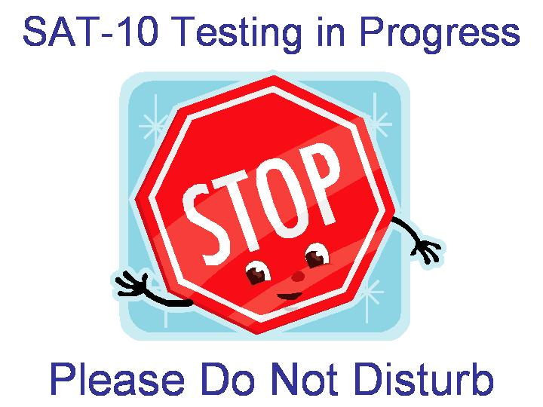

Do Not Disturb Sign
TESTING IN PROGRESS
Please Do Not Disturb

MIAMI-DADE COUNTY PUBLIC SCHOOLS
DISTRICT ASSESSMENT PROGRAMS

RECORD OF ABSENCES, EXEMPTIONS, AND INVALIDATIONS

Assessment Program: ___AAGTP_______________________ Assessment Date: __________ (Month/Year)

Name of School: ____________________________________ School Location Number: _______________

Name of Test Administrator: __________________________

STUDENT’S NAME | CODE  A = Absence  E= Exemption  I = Invalidation | SUBTEST  R = Reading  M= Mathematics | REASON
Place the completed form in Box #1 of the “To Be Scored” test materials. The test chairperson should retain a copy of this form for one year following the assessment date.
DUPLICATE AS NEEDED FM-5183 Rev. (04-09)
MIAMI-DADE COUNTY PUBLIC SCHOOLS

TEACHER COUNT SHEET

Assessment Program: AAGTP

School Name: _____________________________________________________________ School Number: ____________

Directions: Record the teacher’s name and quantity of test booklets, ID Header Sheets, program guide, and/or administration script assigned to each test administrator. Teachers must certify receipt/return by initialing this form when picking up materials prior to testing and again when returning materials after testing.

Teacher’s  Name | Number of Test Booklets | Number of ID Header Sheets | Number of Copies of the Directions for Administering/  Administration Scripts | Date  __/__/__  Receipt/  Return and Initials |  | Date  __/__/__  Receipt/  Return and Initials

Test Chairperson’s Signature: _________________________________________________ Date: ___________________

Place this completed form in Box #1. Retain a copy of the completed form at the school for one year following the administration date.
DUPLICATE AS NEEDED M-4661 Rev. (08-07)
37
MIAMI-DADE COUNTY PUBLIC SCHOOLS

RETURN PACKING LIST FOR “TO BE SCORED” MATERIALS
2014 ADMINISTRATION

Assessment Program: Alternative Assessment for Grade 3 Promotion

School Name: _____________________________________________ School Number: _______________________

Total Number of “To Be Scored” Boxes from School: N/A________________________________________________

Directions: Complete this form by writing in the number of “To Be Scored” Materials being returned. Write N/A if not applicable for this assessment.

Testing Material | Number of Materials
Used Test Booklets/ID Header Sheets (submitted for scoring)
ID Header Sheet(s) Coded “Absent”
Test Booklet(s) and ID Header Sheets(s) Coded “Invalidated”
Total Number Submitted (Sum of Rows 1 through 4)

DO NOT INCLUDE “NOT TO BE SCORED” MATERIALS” IN THE COUNT.

Test Chairperson’s Signature: ______________________________________ Date: _________________________

Place this completed form in Box #1. Retain a copy of the completed form at the school for one year following the administration date.

DUPLICATE AS NEEDED

MIAMI-DADE COUNTY PUBLIC SCHOOLS

RETURN PACKING LIST FOR “NOT TO BE SCORED” MATERIALS
2014 ADMINISTRATION

Assessment Program: Alternative Assessment for Grade 3 Promotion

School Name: _____________________ School Number:_____________________

Total Number of “Not To Be Scored” Boxes from School: ____________________________________________

Directions: Complete this form by writing in the number of testing materials being returned. Write N/A if not applicable for this assessment.

Testing Material | Number of Materials
Damaged Test Booklets
Unused Test Booklets (Blank)
Blank Non-preprinted ID Header Sheets
Unused Preprinted ID Header Sheets for No Shows
Administration Scripts

DO NOT INCLUDE “TO BE SCORED” MATERIALS IN ANY COUNT ABOVE.

Test Chairperson’s Signature: ______________________Date: ________________

Place this completed form in Box #1. Retain a copy of the completed form at the school for one year following the administration date.

DUPLICATE AS NEEDED
MIAMI-DADE COUNTY PUBLIC SCHOOLS

SCHOOL PROCEDURAL CHECKLIST

Assessment Program: Alternative Assessment for Grade 3 Promotion

Documentation that the Alternative Assessment at each school was supervised by the principal in accordance with the guidelines and procedures established by Miami-Dade County Public School district is required. To comply with this requirement, this form must be completed by the school principal and the test chairperson and placed in box#1.

We certify that, to our knowledge, all guidelines and procedures outlined in the Alternative Assessment Program Guide/Test Administration manual have been strictly adhered to at this school, and that each of the following specific processes has taken place as prescribed; as noted below:

Yes No
___ ___ All Alternative Assessment testing materials were received and counted, and any discrepancies were reported and reconciled with the Test Distribution Center prior to the test administration. After reconciliations, if any, our school had sufficient quantities of Alternative Assessment materials to conduct testing.

___ ___ Prior to the test administration, all staff involved in the Alternative Assessment administration were trained on appropriate test administration and security procedures. The Test Security Guidelines/Procedures were reviewed with all persons administering or having access to test booklets either in a faculty meeting, a grade group or department meeting, or individually, if absent from scheduled group meetings.

___ ___ The Alternative Assessment was administered following the explicit directions stated in the appropriate grade level test administration manual to assure test standardization.

___ ___ Following testing, all test materials were accounted for according to the guidelines in the Alternative Assessment manual. Any missing materials reported, by telephone and in writing, to Student Assessment and Educational Testing.

___ ___ All “To Be Scored” documents were delivered to their prescribed destination on the designated date(s).

___ ___ All “Not To Be Scored” documents were delivered to their prescribed destination on the designated date(s).

______________________________ _____________________________
Principal’s Signature Date

______________________________ _____________________________
Test Chairperson’s Signature Date

______________________________ _____________________________
School Name School Number

If any item was marked “No,” a written report of any exceptions to the above procedures must be attached to this checklist when submitted.

Sample Alternative Assessment Grade 3 (ID) Header Sheet

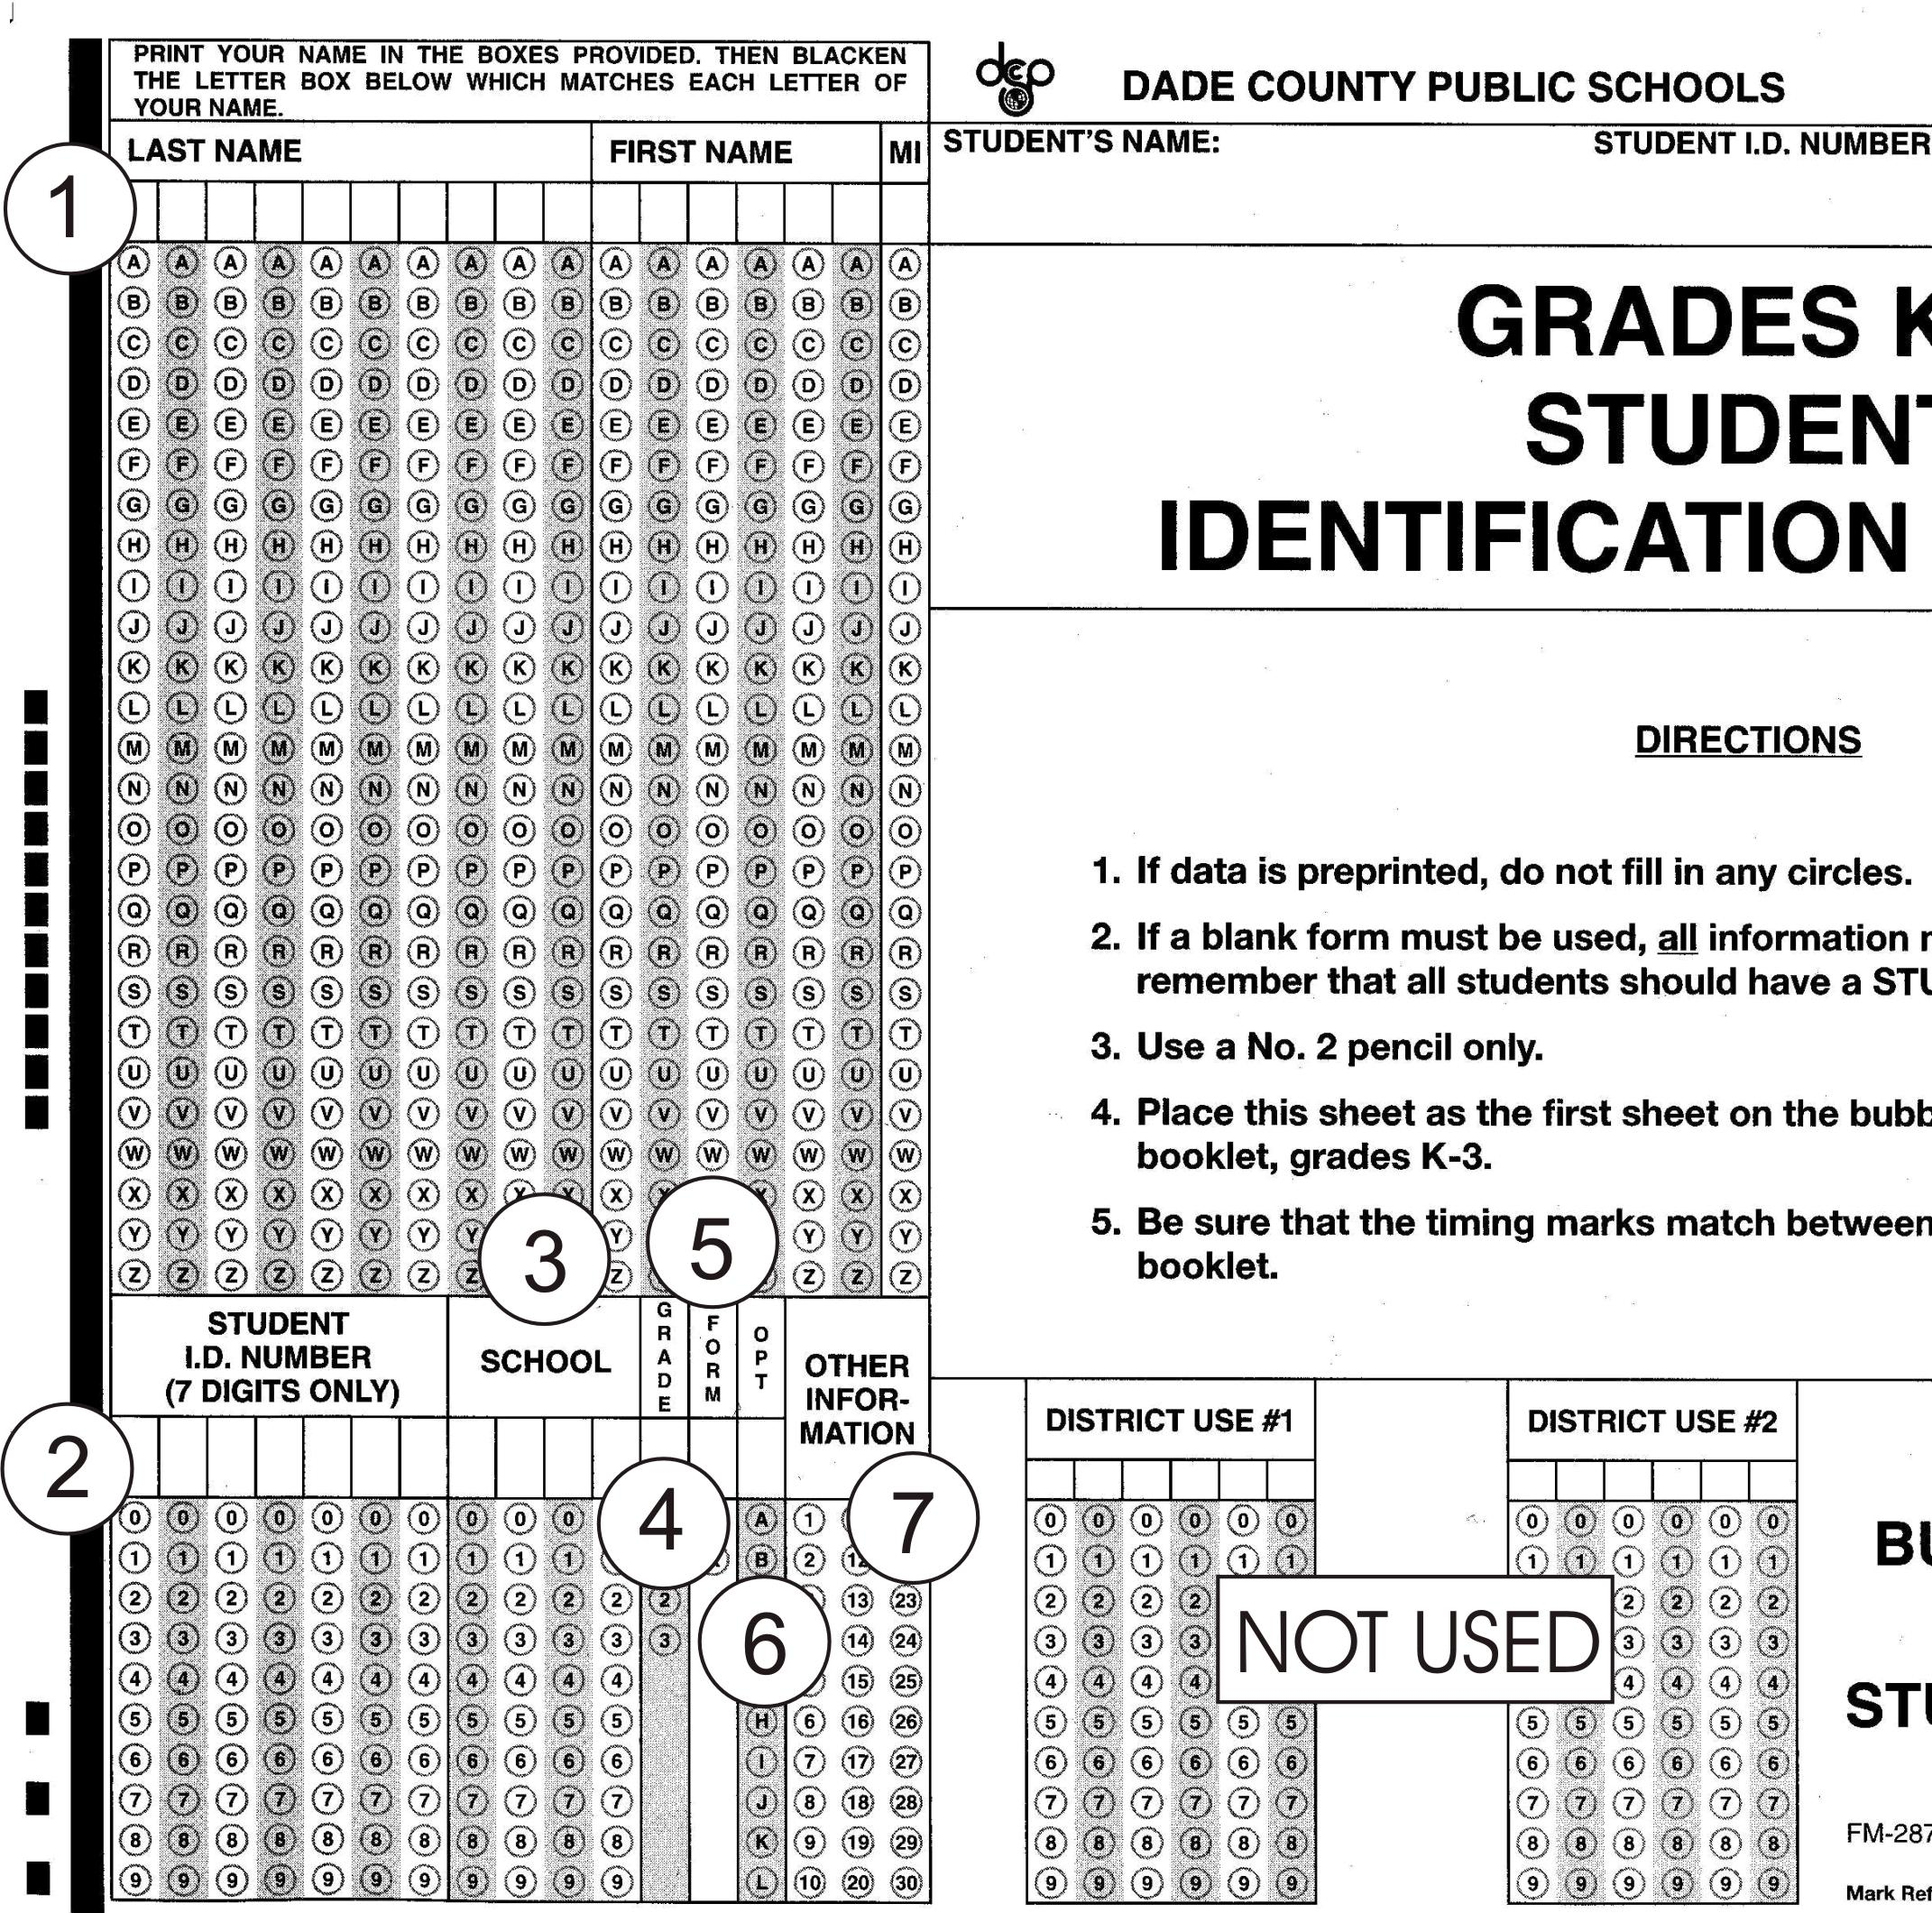

1 = NAME - Beginning at the left: Student's last name, first name, and middle initial
2 = STUDENT'S ID NUMBER - Student's 7-digit ID number
3 = SCHOOL - School's 4-digit location number
4 = GRADE - Student's grade level
5 = FORM - Obsolete (Leave Blank)
6 = OPT (Leave Blank)
7 =OTHER INFORMATION:
5 = ABSENT
6 = INVALIDATED
9 = ACCOMMODATION(S)
See chart on page 7.

APPENDIX E

SCRIPT FOR ADMINISTERING THE TEST

2014 ALTERNATIVE ASSESSMENT
FOR GRADE 3 PROMOTION

Administration Script Page 1 of 3

Say: I am going to give you your test booklet. Don’t open your booklet until I tell you what to do.

Distribute the test booklets. Check to see that each student gets the right booklet. When all students have their booklets,

Say: Open your booklet to the Reading Comprehension section on page 3, where you see the picture of the open book at the top of the page.

Walk around the room to make sure everyone has page 3 showing. Booklets should be open flat, not folded back.

Say: Look at the directions at the top of the page. Read them to yourself as I read them aloud. “Directions: Read each passage. Then read each question about the passage. Decide which is the best answer to the question. Mark the space for the answer you have chosen.”

Now find the sample poem, right below the directions.

Make sure everyone has found the sample poem.

Say: Read the poem quietly to yourselves.

Pause about two minutes while students read the sample poem.

Script reprinted with permission from Pearson.

Administration Script Page 2 of 3

Say: Now look at Sample A.

Read the sample question to yourself as I read it aloud. You can tell that the speaker does not like – A hearing the alarm clock . . . B eating breakfast . . . C mowing the grass . . . D riding in a car. Which is the correct answer?

Pause for replies.

Say: Yes, that’s right. The poem says “Turn it off! Turn it off!” when the alarm clock rings. The space for “A,” hearing the alarm clock, has been filled in to show that it is the correct answer. Does anyone have a question?

Answer any questions the students may have. Repeat the sample, if necessary.

Say: Now look at Sample B. Read the question to yourself. Mark the space for your answer.

Pause while students mark their answer.

Say: Which space did you mark?

Pause for replies.

Say: That’s right. You should have marked the answer space for “D,” Thinking about when you first wake up. Does anyone have a question?

Answer any questions students may have. Repeat the sample, if necessary.

Say: Turn to the next page. You will do the rest of the stories and questions by yourselves. After you finish this page, keep working until you come to the end of page 21, where you see the word “STOP”. If you finish before I tell you to stop, put your pencil down and wait. You may check your work on pages 5 through 21, but do not go on to any other pages. If both your pencils break, raise your hand, and I will give you another one. Does anyone have a question?

Answer any questions. Repeat the instructions, if necessary.

Script reprinted with permission from Pearson.

Administration Script Page 3 of 3

Say: Start working now.

While the children are working, walk quietly around the room to make sure that they are following directions and marking their answers correctly. Check to see that students mark only one answer for each question and that they go on until they finish the questions on page 21. If a student has trouble understanding what to do, explain as quickly and quietly as you can, but try not to waste any testing time. Do not give help on specific test questions.

This subtest is untimed. Allow at least 50 minutes for students to finish.
After 50 minutes or when all students have finished,

Say: Stop. Put your pencil down now. Close your booklet so that the front cover is on top.

Collect the test booklets immediately.

Script reprinted with permission from Pearson.

APPENDIX F: SOURCES OF INFORMATION

For information about when to test, who to test, testing procedures, and testing accommodations, please contact:

Ms. Mayda Cabeza, Director I
Student Assessment and Educational Testing
1500 Biscayne Boulevard, Suite 225
Mail Code: 9023
Phone Number: 305-995-7520
Fax number: 305-995-7522
E-mail: mcabeza@dadeschools.net

For additional testing materials and information on how to pack and when to return materials, please contact:

Ms. Magaly Hernandez, Supervisor I
Test Distribution Center (TDC)
13135 S. W. 26th Street
Phone Number: 305-995-3743

The links to access the Summer 2014 Alternative Assessment for Grade 3 Promotion Training Screencast and the Program Guide are located on the following web page:

http://oada.dadeschools.net/TestChairInfo/InfoForTestChair.asp

At the completion of the screencast training, it will be MANDATORY for you to complete the online Screencast Verification Form at:

https://www.surveymonkey.com/s/3KGXCDV

PLEASE NOTE: Your training cannot be verified without completing this task.

